Lesson 3: Introduction to Advertising and Media

Overview
In this lesson, media makers are introduced to advertising and other persuasive messages. They will learn the ‘language of advertising’ and start thinking critically about advertising. They will also think broadly about media and consider all of the media and places where they see advertising.

Students will review/apply concepts from English Language Arts (ELA) Common Core curriculum related to analyzing the main message and characters in the advertising text, deciphering opinions and facts, and reviewing and practicing descriptive writing.

For nutrition knowledge, they will review the nutritional content and daily requirements for the DAIRY group.

Learning Objectives
Students will:
- Understand the definition and identify the purpose(s) of advertising
- Know that advertising is found in different media. Be introduced to different forms of media.
- Learn to identify the main message (and characters) in advertising
- Review/apply Common Core ELA principles related to opinion and facts, main message/characters, and descriptive writing
- Review nutrition information: milk is part of the Dairy group. Know the different types of food in the Dairy group. Know the daily requirements of the Dairy group.
- Review concepts by practicing writing an creating ads

Time Required:
Part I (about 25 minutes)
Brain Break (3-5 minutes)
Part II (7 minutes)
Part III (7-10 minutes)

Materials:
- Student Packet
- Powerpoint (optional)
- Advertising Examples (if not using Powerpoint)
- Art supplies: crayons or markers (maybe extra paper)
- Snack/Activity: Chocolate milk (optional)
- Brain Break /dice

Common Core Standards

- CCSS.ELA-Literacy.RL.3.1
Ask and answer questions to demonstrate understanding of a text, referring explicitly to the text as the basis for the answers.
- CCSS.ELA-Literacy.RL.3.2
Determine the central message, lesson, or moral and explain how it is conveyed through key details in the text.
- CCSS.ELA-Literacy.RL.3.3
Describe characters in a story (e.g., their traits, motivations, or feelings) and explain how their actions contribute to the sequence of events.
- CCSS.ELA-Literacy.RL.3.6
Distinguish their own point of view from that of the narrator or those of the characters.
- http://www.corestandards.org/ELA-Literacy/W/3/
CCSS.ELA-LITERACY.W.3.1
Write opinion pieces on topics or texts, supporting a point of view with reasons. [note in this lesson they will mainly decode or recognize opinion claims]
6) CCSS.ELA-LITERACY.W.3.1.B Provide reasons that support the opinion.

Part I. What is Advertising? (about 25 minutes). In this section you will introduce the students to the definition and purpose of advertising. They will see an example print advertisement and start ‘decoding’ it in line with Common Core principles investigating the main message, characters etc.

Today we are going to learn about media and advertising. Remember at the end of this unit, we are going to create ads for a healthy food.

What is Advertising?

(Some students may be able to provide an example that could be used to start the discussion. Optional: on the powerpoint is an example of a Ketchup commercial shown in the Superbowl. Could also show the example of a print ad: “Got Chocolate Milk” Peanuts characters advertisement)

(Then write the following definition from MediaSmart on the board (or it’s on a POWERPOINT SLIDE). The definition in the student packet has two blank spots for students to ‘fill in’ the missing words.)

“An advertisement is a paid message that can tell you something you need to know, or which persuades you to buy a product, or which puts forward a point of view.”

What is the purpose of advertising? (note that this information will be in their packet, too)

Say and/or Write down (also on a POWERPOINT slide):
- to provide information
- to persuade us to do something (usually to buy something)
- to promote a point of view or opinion

Using the “Got Chocolate Milk” Peanut advertisement, ask the children:

What information is shared here?

(answer: it is delicious, it is nutritious)

What is it asking us to do? What is the main message?

(answer: this is tricky – the words here ask “got chocolate milk?” so it is asking if you have it. But what it really wants us to do is think about getting it. In your case, can you yourself buy chocolate milk? (answer no) – it is hoping that you will ask your parents).

How is it persuading us? What is in the ad that makes you like it or want to buy it?

(they may not know this yet, this it to get them to start thinking about different ways to persuade.)

Who are the characters in this advertisement?

Do you know who these characters are? They are Charlie Brown and Snoopy. How many of you know them or have seen them on TV? Raise your hands. The milk organization knows that children like characters and Halloween and they probably like chocolate milk, too.

What do you think the characters are feeling in the advertisement?

(Possible Answer: they are happy, they are excited)

How do you know they are happy?

(Possible Answer – they are smiling, they have treats, it is Halloween, they drank chocolate milk)

What is the point of view or opinion here? (POWERPOINT SLIDE – Ad with OPINION)

(answer: that chocolate milk is yummy – it is a good treat…there could be other opinions –you could say that many people have different opinions of advertising – it is a combination of nonfiction material and fiction)

What reasons could you give that would support that opinion? What could you say or write to help us believe that chocolate milk is delicious?

(answer – you could do a taste test and watch children drink it and see how they act, you could ask children what they think. Let’s do that. How many of you think that chocolate milk is delicious? – count hands and write down the number. “10 people think that chocolate milk is delicious. That is a reason to support the opinion in the ad. The people who made the ad or the ad’s author may believe that this opinion is true, but you may believe something else)

In this ad, do they use a fact or information claim?

(answer: no, not really – they are telling you that it is delicious – but that is an opinion – can you circle the opinion in the ad? They should circle “delicious treat”)

Is this ad providing any fact about the claim that milk is nutritious?

(answer – No – it is stating this claim but doesn’t provide specific information. milk provides calcium and vitamin D for strong bones, protein for your body and vitamin A for healthy eyes and skin). But chocolate milk also has some added sugar, which isn’t always as great for your body. It has less sugar than soda.
source: http://efnep.ucanr.edu/files/93482.pdf

Write down (it’s also in their packet: Vitamin D – strong bones, protein for strong body, Vitamin A for healthy eyes and skin)

If the advertising doesn’t give us information, where can we get information about a food product?

(answer: from the label on the product, from the company/product website)

Do you know what this is? (point to nutrition label – on POWERPOINT + student packet) This is a nutrition label for one kind of chocolate milk. I told you there is Vitamin A. What number do you see that tells us there is Vitamin A in a cup of milk? (answer: 25%). Can you circle the number? Is this ALL of the Vitamins you need in a day? (answer no – it is a percentage or part of the daily needs).

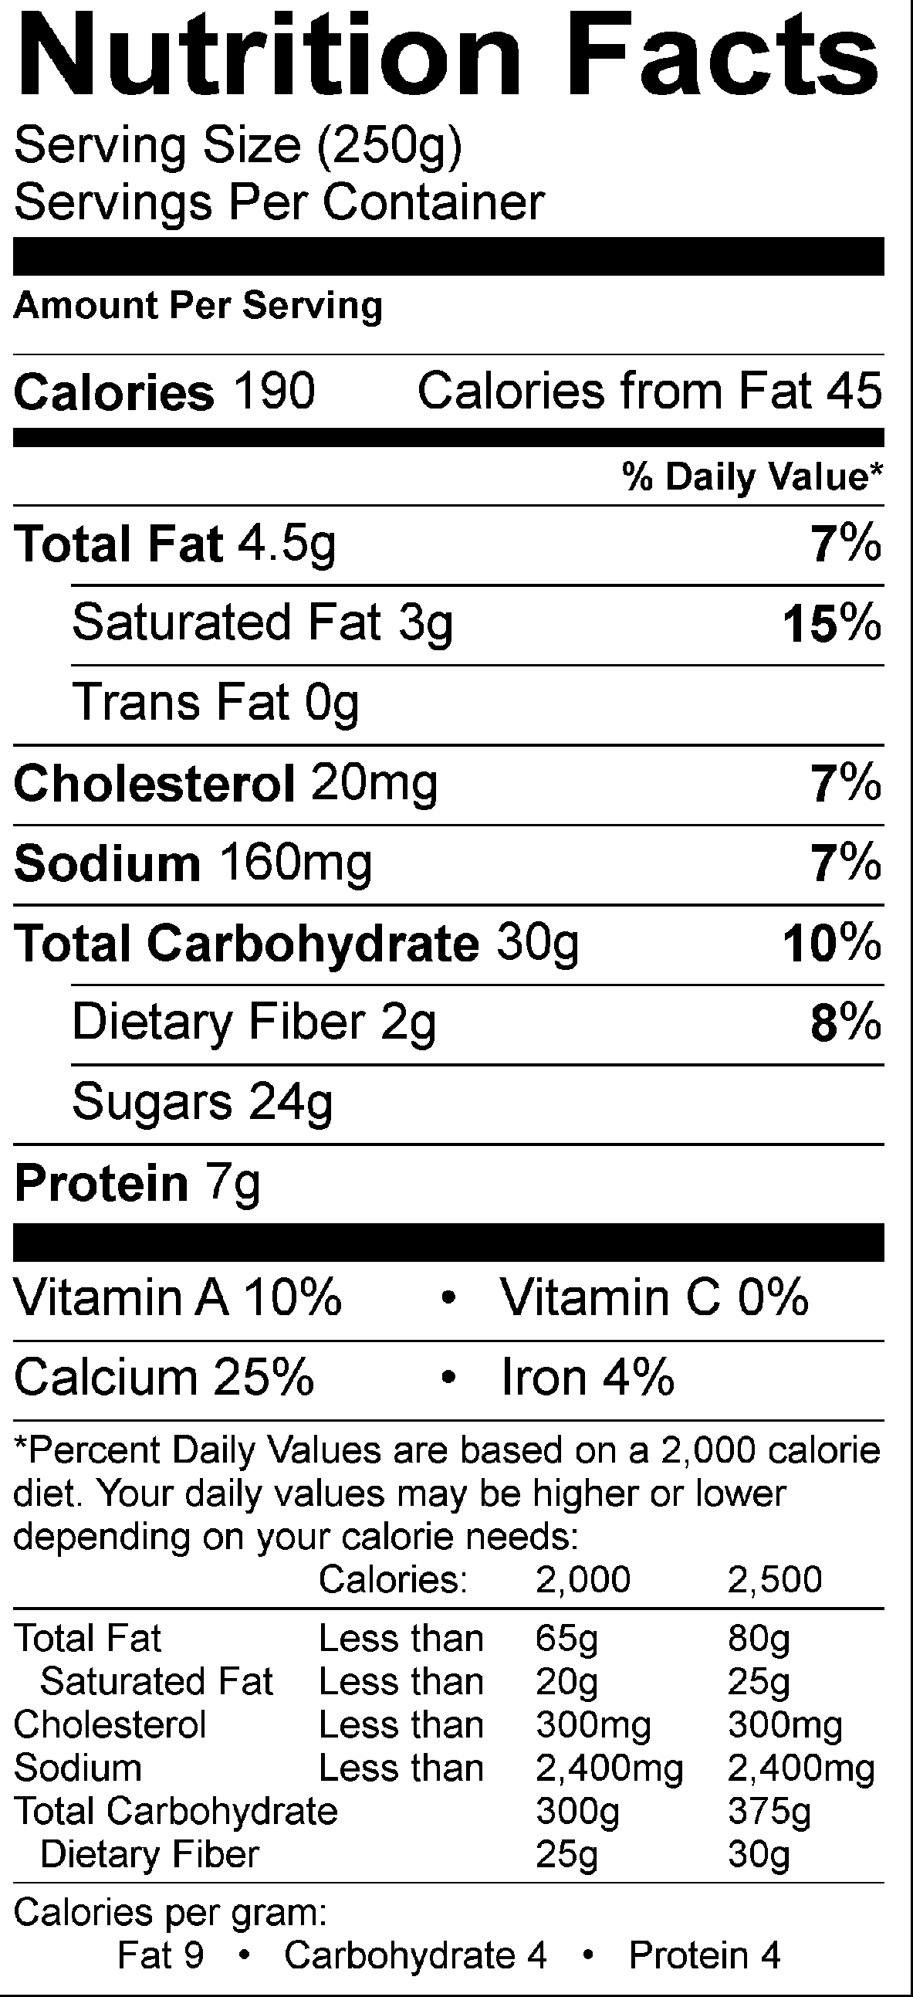

In fact, milk is part of the DAIRY food group.
Do you remember MYPLATE? You can see here that there are many kinds of dairy. Can you name these?

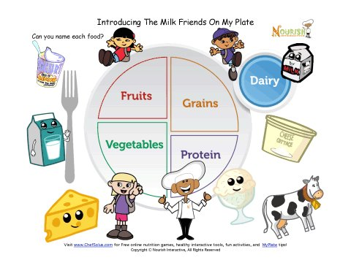Do you know how many foods or drinks you need in dairy each day? If you are 8 years old, you need about 2 and ½ servings/cups and if you’re 9 years old, you need
3 servings or cups.
source: http://www.choosemyplate.gov/food-groups/dairy-amount.html

BRAIN BREAK

OPTIONAL TASTING + ACTIVITY (10 minutes) MILK TASTE TEST AND MAKE AN AD

Now let’s have one serving – let’s taste some chocolate milk or white smilk (SNACK) and then you are going to get to practice making your own ads for milk.

Ask the students to try their milk and circle/color the face in their packet that relates to their opinion of the taste of milk.

Ask: is it delicious? How many of you circled the smily-est face? (could do a tally on the board) How many of you think it’s NOT delicious? (do a tally on the board).

Say: Ok, now let’s describe it. Remember that an adjective is a word used to describe an object. Please take another sip and try to describe milk. Milk is…

[There’s a sheet in the packet that allows the children to write 3 adjectives – this could be done individually or as a class ….some ideas: cold, yummy, smooth…could prompt them: it looks like…, it tastes like…it smells like…)

Say: Ok, now you can make your own ad. Let’s review. We said that advertising can offer information and try to get you to buy the product. Look at the facts and the words you used to describe it and the opinion of the class (point to the tally). You can now try to make your own ad.

[this activity could be done individually – you could let the students try their own ads for 5 minutes – then you could ask for students to volunteer their information or ideas and/or come up to the board and write/draw their ad. Alternatively, you could do this as a group activity where you ask the students for ideas. Some prompting questions may be: which fact(s) should we use (pointing to the nutrition facts)? Which of your adjectives or describing words should go in the ad? What pictures or characters should go in the ad? And then draw/write out the ad on the board].

Great job. Let’s take a picture of our ad to share with others (if you have a camera or smart phone you could take a photo to share with the researchers etc. ).

Part II. Advertising Critique: Truth in Advertising (5-7 minutes). In this part of the lesson, you will convey to the students that food packages are another ‘kind’ of advertising and that advertising does not always show or tell the entire truth. Sometimes you have to ask questions and think about what is true. This is a critical thinking part.

But you need to be careful with advertising. It might not tell you the whole truth. For example, the Got Milk advertisement didn’t tell you that there is added sugar. Ask: why not?

(answer: because then you or your mom may not want to buy it)

Here’s one other example. This is a cereal package. Is this advertising? Show the Cereal “All Berries” Example

[answer – kind of, it’s a form of persuasion. It gives you information, it promotes a point of view and it wants you to buy the product]

Ask: If you saw this package at the grocery, what would you think it is made of? What is inside this cereal?

(The students will probably (hopefully) say “Fruit.” Then you show them the ingredient label (it’s also in their packet))

Ask: How can you tell what is really inside the food?

(Remind them to look at the side or back of the package on the ingredient label. Show them that the first five ingredients – which tell you what is mostly in the food – does not list any kind of fruit. Tell them that sometimes advertising exaggerates or tries to show you visuals that are not always the complete truth. They need to be detectives to ‘decode’ the media)

Part III. Advertising Around Us: Many Media Options (different kinds of advertising, media forms, media ubiquity) – 7-10 minutes. In this section you will ask them to think about all the places where they see advertising and you will introduce them to the traditional kinds of media (e.g., TV, radio, newspaper).

Ask: We saw a print ad in a magazine (refer to Chocolate ad). We saw the cereal package. Where else do you find advertising?

(Ask the children where they have seen advertising today – at home or on their way to school. You could prompt them with questions such as: did anyone see TV today or hear radio? Did you pass any billboards or signs on the way to school? Did your parents read a newspaper or magazine? Can you remember any advertisements? As you are saying each different medium, you could hold up the appropriate “Media Card” and the Tape it to the Board)

Sometimes, there are other ways to tell you about a product or to persuade you. Where are other places where you see messages about products or names of products?

You could prompt them with questions such as: on the Internet – before they watch a Youtube video, when they are playing a computer game, on product packages, or even on clothing. You could ask the children to look around the room and see if they see any brand names /names of products on other people’s clothes, shoes, or backpacks (note: brand names even include sports teams).

There are many places where you see advertisements. Here are many places, can you name them? POWERPOINT SLIDE shows Bus, Radio, Billboards, TV, newspapers, movie theatres, magazines, computers, retail/stores …

Ask them: How many advertisements do you think you will see /come into contact with in a day?

(Encourage them to guess. Then tell them that no one really knows the exact answer, but it is probably between 500 and 1,000 ads. There is a lot of money spent on advertising. The money that companies spend to put advertising on TV or radio lets us see the shows for free.)

Ask them: What kinds of products do you think are advertised to kids the most? (or what kinds of advertising do they see?)

(Encourage them to guess. Then tell them that products advertised most often to kids include “sometimes” foods such as candy or fast food or toys. Tell them that we are going to use advertising to tell people about some healthier food just like in the milk ad.)

Review:
Today, we learned about what is advertising, what it is designed to do, and we examined closely this one ad. We also practiced making our own ad. Finally, we learned that advertising is all around us. We will learn more the next time.

