**Lesson 5: Advertising Process and Research**

Overview

In this lesson, media makers are introduced to how advertising and other media messages are made, including “public service advertising.” They will also begin the very first step of the process: learning how to conduct research: both secondary research (e.g., finding and analyzing existing information sources) and primary research (conducting a survey /asking questions). As part of the research, they will review how to find /evaluate sources for research and review/apply concepts from Math Common Core curriculum related to measurement (bar graphs).

In this lesson, students will learn more about their featured “product” for the advertising campaign – broccoli and review principles for target audience.

Learning Objectives

Students will:

1. Gain awareness of the process of how to create media /advertising messages.
2. Be introduced to the concept of “public service advertising”
3. Understand the kinds of research that are conducted; be introduced to concepts of secondary and primary research.
4. Practice conducting and analyzing research
5. Review/apply Common Core mathematic principles related to measurement and data (bar graphs)
6. Review 60-minute daily exercise guideline as part of public service campaign targeting youth

Time Required:

Part I (15 minutes)

Brain Break (3-5 minutes)

Part II (20 minutes)

Brain Break (3-5 minutes)

Part III (7-10 minutes)

Materials:

1. Student Packet
2. Powerpoint (optional)
3. Ads or visuals if not using powerpoint
4. Art supplies: crayons or markers/extra paper
5. Snack (optional): broccoli
6. Optional: Any supplemental materials (library?) on broccoli

Common Core Standards

1. Math: Measurement and Data

Represent and interpret data.

MD.3 Draw a scaled picture graph and a scaled bar graph to represent a data set with several categories. Solve one- and two-step "how many more" and "how many less" problems using information presented in scaled bar graphs.

2. Writing standards:

Conduct short research projects that build knowledge about a topic.

Recall information from experiences or gather information from print and digital sources; take brief notes on sources and sort evidence into provided categories.

**PART I. THE ADVERTISING PROCESS (about 15 minutes).** **In this introductory session, the students will be introduced to the process by which advertising and other media messages are made. They should understand that it usually takes more than one person to make an ad and there is much research, planning and creativity involved. The students will then follow all of these steps for their final project (in an accelerated fashion☺) .**

Today we are going to learn about how advertising and media messages are made. Does anyone have any ideas?

(they may say a number of things here – the focus is usually on creating – there is usually not much knowledge about the background research or thinking).

Well, a lot of people usually make an advertising or media message. This graphic and the summary of 5 steps below are in the student packet. POWERPOINT



It takes many people and many steps to make an advertisement or media message: (1) **research** /find information about product/people (audience)

(2) making a **plan:** thinking about the best way to organize the information

(3) **brainstorming:** thinking of many ideas for words and pictures

(4) **creativity:** practicing making creative ideas (words, pictures) that fit the plan

(5) **research:** make sure the audience will like the ad ideas

Advertising Example: DISCOVER THE FOREST

This is an example of an outdoor ad or billboard. (this ad and the question are in the student packet)

What is the main message?

1. that you should buy a tree;
2. that children may be curious and learn in the forest - ANSWER
3. that children are bored in the forest
4. that you should buy a flower blossom

How do you know that?

(answer the girl is smiling, the headline reads: where curiosity blossoms and the Discover the Forest.org)

Who is the sponsor?



This is a special type of advertising called **Public Service Advertising**. Instead of advertising a product to buy, it is advertising something that is good for the public – like visiting the forest, recycling, or being careful with matches so you don’t start a fire. The sponsor is the Forest Service Department of Agriculture. The Advertising Council is a special organization/group that helps make these kind of messages. Usually, they do not need to pay to be on TV or on a billboard because they are this special kind of advertising. Sometimes people who make advertising work at an **Advertising Agency.** They create these kinds of advertising for free.

How did they make this ad?

They first did some research. They found out that:

**88% of kids today say they like being in nature, and 79% wish they could spend more time there.**

How many of you like being in nature? (the woods)? How many of you wish you could spend more time there?

Next they found that:

Research shows there are many benefits to kids spending time in nature. This time spent outdoors gives children the ability to explore, use their imaginations, discover new wildlife and engage in unstructured and adventurous play.

This campaign seeks to raise awareness of these benefits, inspiring young people to discover the joy of exploring the natural world, and encouraging families to experience nature first-hand.

Source: <http://www.adcouncil.org/Our-Work/Current-Work/Family-Community/Discovering-Nature>

Does this ad make you want to visit nature?

(answer will vary. If no, ask them: What would help you to want to visit nature? If time allows).

OPTIONAL – NEEDS POWERPOINT: Public service advertising can use other media, too. Like TV or radio. Here’s a TV commercial.

Do you recognize the characters? (From movie Rio 2). Do you like this ad?

(Another thing you could point out: on the website – they have different ‘versions’ for target audiences – it’s interesting that it’s even labeled: general market, Spanish language, African American. You could play the different versions and ask the students which audience it is for. This may be especially good for a diverse student body in your classroom for them to see ‘themselves’ in the advertising. Research shows most ads feature Caucasians in the USA).

Remember that it is recommended that you do some form of physical activity every day for up to 60 minutes – that is 1 hour. Hiking or walking in the woods is an example of a physical activity.

Source:

<http://www.choosemyplate.gov/physical-activity/amount.html>

[then you got back to explain the advertising process:]

After they did this research, then they thought about the target audience: children like you. Then they thought of many many ideas and tried to figure out what the main message should be. Then, when they agreed on one idea, they made a plan or an outline of what they wanted. They wrote it down on a paper called a brief. Next the creative team – usually someone does the art or the video and the other person is the writer – got together and doodled and wrote down all kinds of ideas – maybe 200 ideas. After that, maybe they asked children what they thought of the ideas – or maybe the sponsor picked the best idea. And then, they actually started making the ad.

This is kind of what we’re going to do – in a small way – in this class. We’re going to do some research, think about the target audience, make a plan and create lots of ideas for art and words about our product.

BRAIN BREAK

**PART II. Research (about 20 minutes).**

**This section will review and/or introduce primary and secondary research – mainly about broccoli and a little about the target audience: third-grade students.**

**Step 1: Research**

The first thing media people do is the same as when you do any new project – you do your research.

What kind of research have we done so far in this class?

(this depends on the class projects – you could remind them of a science project or other project where the students needed to gather/analyze information and write about it).

Today we are going to do some research about our PRODUCT: broccoli (target vegetable/fruit) and our AUDIENCE: third-grade students.

Where might we find information about this food?

(answer: will vary - farmers, books, food labels, websites, grocery store)

We could find information that already exists in books or websites. This is called **secondary research information**.

How or where could we search for information?

(answer on the Internet> We could search for broccoli - )

How do we know that?

We also want to know information about how people feel about the product and we want to know about it ourselves. So in this case we want to try it and we want to ask other people about it. This information does not already exist, we need to find and collect the information ourselves. This is called **primary research.**

PPT slides show secondary research info (also in packet):

1. “Broccoli is a hardy vegetable of the cabbage family that is high in vitamins A and D. It develops best during cool seasons of the year.”

2. 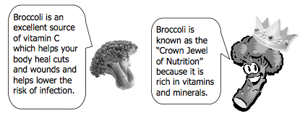

3. Food label:

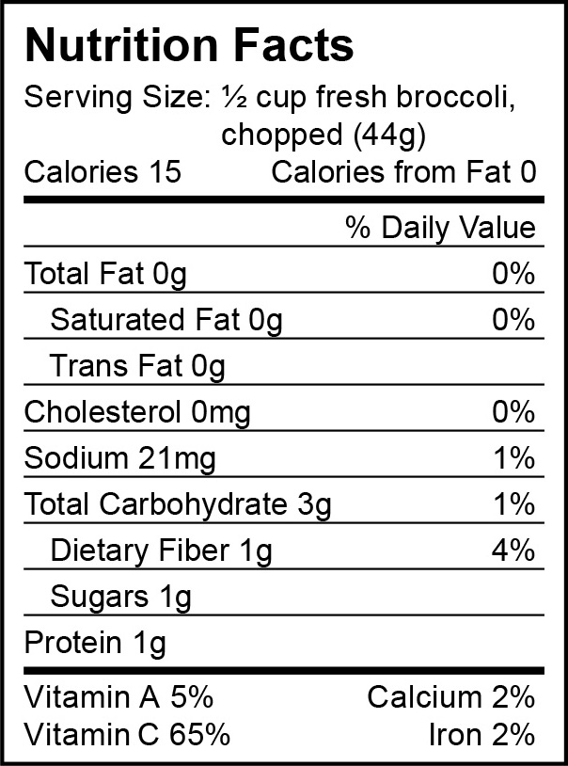

Another way we can do research about food is to check the labels. Here is a label – nutrition facts for broccoli. What do you notice about it?

What does it NOT have in it? (fat)

What does it have only a little of? (protein, sugars)

What does it have a lot of? (Vitamin C)

Let’s do some primary research.

Sometimes when you want to find out information, you ask people. Since you are the target audience for broccoli, I’m going to ask you some questions. (POWERPOINT)

|  |  |  |  |
| --- | --- | --- | --- |
|  | **YES** | **NO** | **Total** |
| Have you tried broccoli? |  |  |  |
| Do you like broccoli? |  |  |  |
| Does your family buy broccoli? |  |  |  |
| Do your friends like broccoli? |  |  |  |

(you could ask them to stand up or raise their hand for “YES” and do a tally)

How could we make a bar graph to show that information?

(there’s an example bar chart in the student packet –and POWERPOINT you could refer to that one and/or draw one for the tally data on the chalk board) .

OPTIONAL: Good – now we’re going to review bar graphs – you get to practice (if time allows) – there is a worksheet in the packet: Reading a Bar Graph: FAVORITE VEGGIES: PRACTICE Go over this sheet or skip it and go on with primary research

OPTIONAL: TASTE TEST. Bring in/have broccoli from cafeteria (?) – could encourage the students to try and it also ‘pair’ it with other dips such as hummus, ranch dressing or lemon on top.

DESCRIBING/BRAINSTORMING

The POWERPOINT and student packet has several forms to get the students to think about ways to use the senses/adjectives to describe vegetables.

You could also encourage free association – other ways to think about it.

Other ways you could do primary research about broccoli

* Go to the grocery store and see how people are shopping in the produce (vegetable) section
* Watch people eating broccoli (or other vegetables) in the cafeteria
* Ask people questions about broccoli
* Try recipes and do a ‘taste test’

BRAIN BREAK

**Part III. Target Audience (about 7-10 minutes). This section applies ‘research ideas’ to the concept of the audience for the message. They need to think about themselves. There are places in the student packet for them to fill in the blanks if time for the questions posed below.**

When you are creating messages, you need to know about the target audience (the people you want to see your message). You should know what they like to do – what they believe in – and their behavior with respect to the product. In our case, we’re interested in food – so we want to know how and what and why they eat certain foods.

We could learn about our audience the same way that we learned about broccoli – by finding information and by asking questions.

**What do they like to do?**

**What do they like to eat?**

**How can we convince them to eat broccoli?**

Review – Advertising Process

Today we learned a little about advertising is made and we did this first step – research. Research means finding out information about the product and the target audience. Next time we will write the strategy/plan – think of ideas – and actually write and create our ads. Remember, usually it takes a team effort. Some people do the research, some people do the plan, other people do the writing and other people make the art. We are doing all of these steps in this class.