***Making Media for a Healthier U***

Pilot Curriculum: Third-Grade Teacher Packet

Waukegan School District - May 2014



The Waukegan Public Schools is in partnership with researchers at the University of Illinois to improve the health and media literacy skills of students in elementary schools in Waukegan. We are in the first phase of this project.  The goal of the project is to improve the health of every student through increasing nutrition knowledge and gaining media literacy skills while learning core curriculum in the classrooms. Students will learn about nutrition and media while they are also practicing math and writing skills.  We are starting with some of the third grade classes in May 2014. For more information, please contact Dale Kehr, Extension Educator, Illinois Nutrition Education Program (847-223-8627) or dalekehr@illinois.edu or Michelle Nelson, Associate Professor of Advertising at [nelsonmr@illinois.edu](mailto:nelsonmr@illinois.edu).

Welcome! Some of the things you’ll be teaching in this unit are:

* Learning about healthy foods and nutrition
* Learning about different kinds of advertising
* Learning how advertising is made
* Practicing some math, research and writing related to healthy foods such as fruit, dairy, and vegetables
* Creating a real advertising campaign for a vegetable

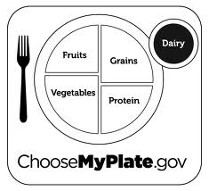

“Making Media for a Healthier U”: Waukegan Pilot Curriculum Overview (May 2014)

Young people today are exposed to more and more media than ever before. Yet, research shows just because children consume media does not mean they are able to think critically about the media messages. We developed this curriculum so that children can understand and think critically about media so that they can make more informed choices. The curriculum is designed to introduce students to health and nutrition content while they are learning about media and advertising and they review and apply lessons from the Common Core curriculum.

Media Makers understand, analyze, critique and create media messages to promote healthy behaviors. Media literacy and nutrition information are incorporated into Math and Language Arts Common Core lessons for elementary school children (grade 3).

Students in this pilot project will first learn or review nutrition and healthy lifestyle information in two lessons (including myplate food groups and reading nutrition labels) and then in four lessons they will learn (1) how to decode and critique ads; (2) the process of creating advertising by conducting some research, making a plan, practicing writing and producing art, and actually creating advertising messages to convince their peers to eat a healthy food (broccoli). Advertising messages will be featured on the Illinois EXTENSION and/or Department of Advertising - Illinois website.

We thank you for your participation in this pilot! We know about the nutrition content and the advertising, but we look forward to receiving your feedback on these lessons so that we can improve them for the future for the classroom.

Overview of Lessons (for Pilot – Spring 2014; 6 lessons – about 6 hours of curriculum)

Tentative Schedule:

Friday, May 9/Monday, May 12: Pre-test to all control and test classrooms

Tuesday, May 13: Lesson 1: Using the Dietary Guidelines to a Healthier You

Wednesday, May 14: Lesson 2: Reading Food Labels and Understanding Requirements for Physical Activity

Thursday, May 15: Lesson 3: Introduction to Advertising and Media

Friday, May 16: Lesson 4: Decoding Media: How and Why Advertising Works

Monday, May 19: Lesson 5: Advertising Process and Research

Wednesday, May 21: Lesson 6: Advertising Message Strategy and Creativity

Friday, May 23: Post-test to all control and test classrooms

**Overall Learning Objectives:**

**Fruit and Vegetables/Nutrition (MyPlate):** <http://www.choosemyplate.gov/kids/downloads/ServingUpMyPlate-level2-TeachersGuide.pdf>

Students will be able to:

1. Understand their dietary guidelines by age group
2. Identify and describe the five main food groups and name a variety of nutritious examples of foods in each.
3. Discuss the importance of physical activity as part of a healthy lifestyle and know the recommended physical daily activity
4. Understand the idea behind “Portion /serving size” and be able to calculate serving size from package label
5. State the benefits of eating a healthy diet and maintaining proper physical activity

**Packages and Food Labels**

Students will be able to:

1. Understand that food packages are a form of ‘advertising’
2. Be critical of front-of-package visuals and claims
3. Become familiar with food labels
4. Understand food label concepts and numbers related to serving size and calories
5. Become familiar with the ingredient list (e.g., first ingredients, Vitamins)

**Advertising/Media**

Students will be able to:

1. Understand the purpose of advertising
2. Understand the process of how advertising is developed; practice the process of how advertising is developed
3. Understand the concept of target ‘audience’
4. Describe the parts of a ‘print ad’ (e.g., headline, main message, how visual relates to words, etc.)
5. Review the types of advertising messages and persuasive appeals (e.g., celebrity, information)
6. Gather and evaluate primary and secondary research information related to the healthy food and the audience
7. Practice the creative process (brainstorming) related to the product, audience, and media message;
8. Create messages (visuals and words) for the healthy product
9. Present and discuss the healthy messages to their peers and the class

**Common Core Objectives**

Given that this curriculum is delivered at the end of third grade, the lessons are designed to review Common Core materials at this grade level.

<http://www.isbe.net/common_core/pls/level1/pdf/ela-standards.pdf>

Please note that in this 6-hour pilot, the emphasis on these standards is on some review /repetition of these concepts. Such standards would be emphasized more completely in a 30-36-hour curriculum.

For example, in Reading Standards (pgs. 12, 13, 14 of pdf above), the advertisements are texts to decode and decipher:

Students will be looking for “key ideas and details” in the advertising messages. They will:

1. “Ask and answer questions to demonstrate understanding of a text, referring explicitly to the text as the basis for the answers.”
2. “….determine the central message, lesson or moral and explain how it is conveyed through key details in the text.”
3. “Describe characters in a story (e.g., their traits, motivations or feelings) and explain how their actions contribute to..” the meaning of the text.
4. “Determine the meaning of words and phrases as they are used in a text, distinguishing literal from nonliteral language”
5. “Distinguish their own point of view from that of the narrator (author/creator) or those of the characters.” (Informational text: “Distinguish their own point of view from that of the author of a text”).
6. “Explain how specific aspects of a text’s illustrations contribute to what is conveyed by the words in a story (e.g., create mood, emphasize aspects of a character or setting).”
7. “With prompting and support, describe the relationship between illustrations and the text in which they appear (e.g., what person, place or thing or idea the text an illustration depicts).”

Writing Standards (pgs. 20, of pdf link above), the students will learn to identify opinion statements versus informative/explanatory statements in advertising texts. They will also practice:

1. “Write opinion pieces on topics or texts, supporting a point of view with reasons.”
2. “Write informative/explanatory texts (statements) to examine a topic and convey ideas and information clearly”

Language Standards

<http://www.k12reader.com/common-core-standard/conventions-standard-english/l31/>

Language: Conventions of Standard English

L.3.1.: *Demonstrate command of the conventions of standard English grammar and usage when writing or speaking.* This standard suggests students understand the function of nouns, pronouns, verbs, adjectives, and adverbs as well as regular and irregular nouns/verbs, abstract nouns, comparative and superlative adjectives, and other conventions and sentence types. The lessons will focus mainly on ADJECTIVES. Refer to this [official Common Core Standard page](http://www.k12reader.com/common-core-standard/conventions-standard-english/l31/%22%22http:=%22%22%20www.corestandards.org=%22%22%20ela-literacy=%22%22%20l=%22%22%203%22=%22) for more information.

Mathematics

1. Measurement and Data

Represent and interpret data.

1. Draw a scaled picture graph and a scaled bar graph to represent a data set with several categories. Solve one- and two-step "how many more" and "how many less" problems using information presented in scaled bar graphs.

2. Operations and Algebraic Thinking

Represent and solve problems involving multiplication and division.

Speaking and Listening standards:

1. Comprehension and Collaboration:

1. Engage effectively in a range of collaborative discussions (one-on-one, in groups, and teacher- led) with diverse partners on grade 3 topics and texts, building on others’ ideas and expressing their own clearly.

1. a. Come to discussions prepared, having read or studied required material; explicitly draw on that preparation and other information known about the topic to explore ideas under discussion.
2. b. Follow agreed-upon rules for discussions (e.g., gaining the floor in respectful ways, listening to others with care, speaking one at a time about the topics and texts under discussion).
3. c. Ask questions to check understanding of information presented, stay on topic, and link their comments to the remarks of others.
4. d. Explain their own ideas and understanding in light of the discussion.
5. 2. Determine the main ideas and supporting details of a text read aloud or information presented in diverse media and formats, including visually, quantitatively, and orally.

3. Ask and answer questions about information from a speaker, offering appropriate elaboration and detail.

**BRAIN BREAKS**

**(Roll a dice. The first number chooses the activity from the first column. Roll it again. The second number chooses an exercise from the second column. Do both at the same time to create a “brain break.”)**

**Column 1 Column 2**

|  |  |
| --- | --- |
| **Sing the food groups song!**  (to the tune of Head, shoulders, knees, and toes. Knees and toes)  Fruits, proteins, dairy, grains. Vegetables.  Fruits, proteins, dairy, grains. Vegetables.  MyPlate is filled with healthy edibles.  Fruits, proteins, dairy, grains. Vegetables. | **Dance Party!** |
| **Categories – Items in the Dairy Food Group**!  (Go around the room and say as many foods/drinks in the dairy food group as the students can think of, without repeats!) | **High Fives!**  (Go around the room and give high fives to five different people) |
| **Categories - Adjectives that describe fruits!**  (Go around the room and say as many adjectives that describe fruits - or a specific fruit - as the students can think of, without repeats!) | **Jumping Jacks!** |
| **Fact or Opinion?**  (Grab a partner and say either a fact or an opinion about their favorite fruit or vegetable. The partner says whether it is a fact or an opinion. Then it’s his/her turn!) | **Elbow to Knee!**  (Touch your right elbow to your left knee then switch the left elbow to right knee for two minutes) |
| **Spell It Out!**  (Have three students say their favorite food group - or food in a food group - and have the class spell them out) | **Twist and Pass!**  (Grab a pen. Get a partner and stand back to back with your feet planted on the ground, then twist around right to left passing the pen back and forth) |
| **Story Time!**  (Go around the room and have each student say a word or phrase to make up a story. You can start them off with: “Once upon a time, Amelia Apple was stuck on vegetable island and…”) | **Rockstars**!  (Play air instruments: you can play drums, guitar, etc!) |

**Making Media for a Healthier U**

**Lesson 1**

**Lesson Title: Using the Dietary Guidelines to a Healthier You.**

**Common Core Standards Addressed:**

**Conventions of Standard English:**

CCSS.ELA-Literacy.RL.3.6

Distinguish their own point of view from that of the narrator or those of the characters.

**Integration of Knowledge and Ideas:**

CCSS.ELA-Literacy.RL.3.7

Explain how specific aspects of a text's illustrations contribute to what is conveyed by the words in a story (e.g., create mood, emphasize aspects of a character or setting)

**Students will be able to**:

1. Understand their dietary guidelines by age group.
2. Identify and describe the five main food groups and name a variety of nutritious examples of foods in each.
3. Discuss the importance of physical activity as part of a healthy lifestyle and know the recommended physical daily activity.

**Time Required**

45 - 60 minutes - The time will be in 12 -17 minute increments followed by a 1 – 2 minute brain break.

**Materials**

**Resources for background knowledge for the teacher:**

[**http://www.fns.usda.gov/multimedia/tn/sump_level2.pdf**](http://www.fns.usda.gov/multimedia/tn/sump_level2.pdf)

[**http://www.fns.usda.gov/tn/popular-events-booklet**](http://www.fns.usda.gov/tn/popular-events-booklet)

[**http://www.cnpp.usda.gov/Publications/DietaryGuidelines/2010/PolicyDoc/PolicyDoc.pdf**](http://www.cnpp.usda.gov/Publications/DietaryGuidelines/2010/PolicyDoc/PolicyDoc.pdf)

These three links will provide some of the background used in this lesson.

This quote taken from the 2010 Dietary Guidelines sums it up rather nicely.

**Based on the most recent scientific evidence review, this document provides information and advice for choosing a healthy eating pattern—namely, one that focuses on nutrient-dense foods and beverages, and that contributes to achieving and maintaining a healthy weight. Such a healthy eating pattern also embodies food safety principles to avoid foodborne illness.**

If you are using these lessons please make sure you have the current Dietary Guidelines as stated in the quote this material is based on the most recent evidence and from time to time new research will show different results which would require modification to the lesson.

**Inform the students about the program:** Explain that today is the beginning of an exciting new two-week unit where they get to learn about healthy food and actually make advertising messages to tell their friends about why the food is good for them. The “best” messages will be put on a website and shared with students everywhere.

Explain to the students:

Some of the things we’ll be doing are:

* Learning about what are bodies need to be healthy- The Dietary Guidelines
* Learning about the different food groups
* How to read a food label
* Learning about different kinds of advertising
* Learning how advertising is made
* Practicing some math and writing related to healthier food
* Creating real advertising campaigns for the healthier food

This will be so exciting and fun that I hope you share the new information with your family.

**Lesson Material**

Student packet

Teacher’s slides

**Objective:**

Students will be able to understand their dietary guidelines by age group.

**Ask: Could someone name me a healthy food?**

The responses from the children we hope you hear are something like this: apple, orange, whole grain bread, lean meat, green beans, broccoli etc.

**State:** Our bodies need the right kind of energy/food for us to work at our best level and as we go through the material today we should have a better understanding of what our bodies need.

**Brain Break**: 2 minutes

Have the children stand, stretch up to the sky and down then take right arm and touch left knee and repeat with the left arm and right knee. Do these for 2 – 5 times then beginning the lesson. While doing this it would be a good time to remind the children that physical activity is both good for our bodies as well as our brains.

Knowing that research shows students do better with small amount of information at a time try to keep the discussion and sitting phase to about 17 – 20 minutes and then do a hands on activity if possible or a brain break.

**Inform the students that**:

The Dietary Guidelines are updated every five years. Let’s take a look at an average third grade student might consume on an average day.

|  |  |  |  |  |  |  |
| --- | --- | --- | --- | --- | --- | --- |
| Sex | Age | Dairy * | Fruit ** | Vegetable | Protein | Grains *** |
| Girls | 8-9 | 2 ½ - 3 cups | 1 – 1 ½ cups | 1 ½ – 2 cups | 4 – 5 ounces | 5 ounces |
| Boys | 8-9 | 2 ½ - 3 cups | 1 – 1 ½ cups | 2 – 2 ½ cups | 4 – 5 ounces | 5- 6 ounces |

* * 1 percent or skim milk is recommended at this age
* **Whole fruit, canned or frozen fruit is recommended, juice is ok on an occasional basis
* *** Half the grains should be whole
  + Whole grains are corn, whole wheat, rye, millet, brown rice are examples of whole grains and would be written on the first few ingredient’s list.

**Ask: Do you know how much food you should eat each day?**

Let the children answer

Show the chart above and ask do you see how much you should eat each day? (this is included in your resource section)

Let the children answer

**Objective**:

Students will be able to identify and describe the five main food groups and name a variety of nutritious examples of foods in each.

**Inform the students that**:

Dairy:

Resources for this can be found at this website - <http://www.choosemyplate.gov/food-groups/dairy-counts.html>

**Say:** Our bodies really need us to drink the required amount of calcium because these are our growing years and this is when we build the most bone mass is when we are young.

Tonight check out what percent of milk you drink at home, at school we drink 1%.

Our bodies use calcium for building bones and teeth and this helps us to maintain our bone mass. Dairy products are the main source of how we as Americans receive our calcium there are other ways such as eating yogurt, low-fat cheese there are other foods that can help provide sources of calcium but these are usually the best sources.

These are examples of how to receive the daily recommend allowances for dairy:

* A cup of milk is equaled to 8 ounces
* 1 ½ ounces of hard cheese
* 2 cups of cottage cheese

When teaching fruits and vegetables it is helpful if the students have visuals to identify what a cup or half cup looks like

Show the students what a cup and a ½ cup look like using measuring cups and hands as tools. (Picture in teachers resource slide packet)

Fruit:

Resources for fruit can be found at this website - <http://www.choosemyplate.gov/food-groups/fruits.html>

To receive the recommended amounts of fruit they maybe fresh, canned, dried or frozen or even 100% fruit juice.

The preferred fruit is in its natural state as you receive more fiber in your diet this way.

Ask:

What are some of your favorite fruits?

Let the children tell you what they think is a fruit and then show the slide

|  |  |  |
| --- | --- | --- |
| **Fruit** | **1 cup equivalent** | **½ cup equivalent** |
| Apple | ½ Large 3.25 “ or 1 small 2.5” | ½ cup sliced raw, chopped |
| Orange | 1 large 3 1/16” | 1 small 2 3/8” |
| Banana | 1 large 8 – 9 “ | 1 measured 6” or less |
| Grapes | 32 seedless grapes | 16 seedless grapes |
| Peach | 1 large 2 ¾ “ | 1 small 2” |

100% fruit juice would be equal to 1 cup or 8 ounces and ½ cup of dried fruit is equaled to the 1 cup equivalent.

Fruits do not have cholesterol and are usually low in fat, sodium, and calories compared to other snack type foods. Fruit is a good source of Vitamin C which is important for growth and repair of all body tissues and helps heal cuts and wounds.

**Say:**

Fruit is best in its natural form we can get natural fiber this way. Fruit is also a good source of vitamin C which is important for growth and repair of all our body tissues and helps us heal our cuts and wounds.

Vegetables:

Resources for vegetables for this can be found on this website - <http://www.choosemyplate.gov/food-groups/vegetables.html>

Children at this age need from 1 ½ cups to 2 ½ cups of vegetable again there are many ways to get vegetables in a child’s diet. The easiest way is to have them help with the planning. Below is a chart to give examples of equivalents to help them select the proper recommend daily requirements.

When eating raw leafy greens you need 2 cups for it to be considered as 1 cup from this category and 1 cup of vegetable juice, cooked or raw.

**Ask the Children:**

Tell me some vegetables you eat?

Write these down on the board (optional activity)

You could use a few of the vegetables to do a brain break activity.

|  |  |  |
| --- | --- | --- |
| **Vegetable** | **1 cup of vegetables** | **½ cup of vegetables** |
| Carrots | 2 medium or 12 baby carrots | 1 medium or 6 baby carrots |
| Tomatoes | 1 large or 3” diameter | 1 small or 2 ¼” diameter |
| Sweet Potato | 1 large 2 ¼’ diameter |  |
| Raw leafy greens: Spinach, romaine | 2 cups raw equals 1 cup of vegetable | 1 cup raw equals ½ cup of vegetables |
| Dry beans and peas | 1 cup whole or mashed cooked |  |
| Corn on the cob | 1 large ear 8” to 9” | 1 small ear 6” |

Protein:

Additional resources can be found <http://myplate.gov/food-groups/protein-foods.html>

**Explain**:

For children 8 – 9 years old and not very active you should have between 4 – 5 ounces of lean protein this can be done by using lean meats, poultry, fish, beans and legumes.

**Ask**:

What are some of your favorite protein sources?

Have the children name a few.

Show the chart and discuss how they could get the 4 -5 ounces in a day.

For breakfast you could have one egg

Lunch 1 slice of turkey on your sandwich would probably equal 1 ounce

Dinner could be 1 small chicken breast about 3 ounces

How many ounces of protein did we have today? **Answer:** 5 ounces of protein

|  |  |  |
| --- | --- | --- |
| Protein | Protein that equals 1 ounce | Common Portions |
| Meat | 1 ounce cooked lean beef, pork  ham | 1 small steak (eye of round, filet) = 3½ to 4 ounce  equivalents 1 small lean hamburger = 2 to 3 ounce equivalents |
| Poultry | 1 ounce cooked without skin | 1 small chicken breast half = 3 ounce equivalents |
| Eggs | 1 egg |  |
| Nuts and Seeds | ½ ounce of nuts, 12 almonds  1 tablespoon of peanut butter | 1 ounce of nuts or seeds = 2 ounce equivalents |
| Legumes and Beans | ¼ cup of cooked beans (such as black,  kidney, pinto, or white beans)  ¼ cup of cooked peas ¼ cup of baked beans, refried beans | 1 cup split pea soup = 2 ounce equivalents  1 cup lentil soup = 2 ounce equivalents  1 cup bean soup = 2 ounce equivalents |

**Say**:

Protein provides us with B Vitamins such as niacin, thiamin, riboflavin, B6 other nutrients we get from protein are vitamin E, iron, zinc and magnesium. Iron is important because it is used to carry oxygen in our blood.

We need protein for our bones, muscles, cartilage, skin and blood.

Grains

Resources for this section is <http://myplate.gov/food-groups/grains.html>

**Ask:**

What is a grain?

Children will probably say cereal, wheat bread etc.

**Say**: these are products that are in that category. Very good! Now the guidelines recommend that we get have of our requirements from whole grain. A whole grain would be whole wheat, brown rice, oats, cornmeal, barley items where the grain is mostly intact not processed. (You might need to define the word processed for the students)

|  |  |  |
| --- | --- | --- |
| Product/Grain | Equivalent | Common Serving Size |
| Bagel | 1 “mini’ bagel | 1 large bagel = 4 ounces |
| Biscuits | 1 small ( 2” diameter) | 1 large (3” diameter) = 2 ounces |
| Breads | 1 regular slice | 2 regular slices = 2 ounces |
| Crackers | 5 Whole Wheat, 7 saltines |  |
| Muffins | 1 small 2” diameter | 1 large 3 “ diameter = 3 ounces |

Say:

It’s important for our bodies to stay regular that we eat whole grains on a daily basis. This category also helps us to feel full and helps us reduce constipation. Grains have many good nutrients such as magnesium which is a mineral that is used in building bones and releasing energy from our muscles. As well as B vitamins this is important for a healthy nervous system.

Say:

It’s important that we look at the dietary guidelines as a guide to eating healthy every day. Let’s see if we can make a menu for a day of healthy eating.

Breakfast:

Should always have 3 of the food groups

Lunch and Dinner:

Should have at least 4 – 5 of the food groups

Snack

**Review**:

Today, we learned about the dietary guidelines for your age and gender. We discussed how to create a daily menu. Next lesson we will learn how to read a food label and how physical activity is important to our daily requirements.

**Lesson 2: How to Read a Food Label and Physical Activity**

Overview

In this lesson, we will use what the students have learned in the other lessons and make informed decisions on food products to make healthy choices.

Student will review/ apply concepts from Common Core curriculum related to analyzing the different food groups using math and writing skills to express what their individual dietary guidelines are for their age and gender specifics.

Learning Objectives:

Students will:

1. Understand the idea behind “Portion/serving size” and be able to calculate serving size from package label.
2. State the benefits of eating a healthy diet and maintaining proper physical activity.

Time Required:

Part 1 20 minutes

Brain Break 3 – 5 minutes

Part 2 – 20 minutes

**Materials**

Student Packet

Slides

Pencils

Brain Break Activity Sheet

Additional Food Labels (Optional)

**Common Core Standards**

English

Informational Text

RI.3.1 Ask and answer questions to demonstrate understanding of a text, referring explicitly to the text as the basis for the answers.

RI. 3. 6 Distinguish their own point of view from that of the author of a text.

Math

Represent and solve problems involving multiplication and division.

3.OA.1. Interpret products of whole numbers

Let’s review

We learned what we need in a 24 hour period. Third graders need 3 glasses of milk, 1 - 1 ½ cups of fruit, 2 – 2 ½ cups of vegetables, 4-5 ounces of protein, 5- 6 ounces of grains half of them being whole grain. We talked about how important it is to eat from all the food groups. Today we are going to look at some foods and what nutritional value they provide us by learning to read the Nutrition Facts label or Food Label.

Show the students this 2% Chocolate milk food label it’s in the PowerPoint and in the student packet.

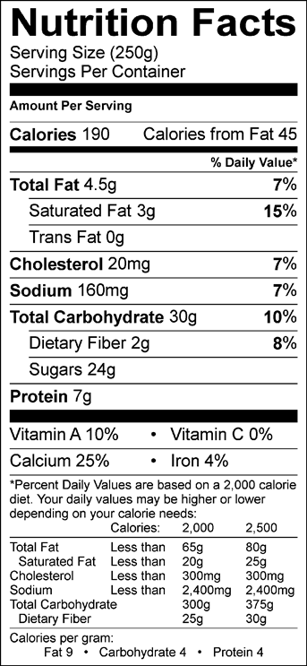

Ask the students what this label tells them.

What you are looking for them to tell you is how many servings per container?

The calorie total

The nutritional value

*In the next label we will show them how to read the label this is just used as an introduction.*

Resources for this lesson are found on -

<http://www.fda.gov/Food/IngredientsPackagingLabeling/LabelingNutrition/default.htm>

Here is one example of a Food Label and how to read it.

Tell the students how to read the food label. This product has 2 servings per container and one serving size equals one cup. There is 250 calories for each serving or each cup. The gold highlighted area you want to limit those nutrients. The red area you want to get enough of those nutrients. The blue area is a reference area comparing the percentages in the food against a 2,000 or 2,500 calorie diet. We want to keep the Fat, Cholesterol and Sodium low 5% or less is best in this category when possible.

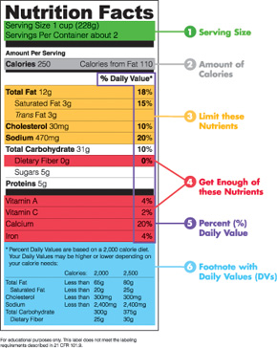

In Student Packet and Your Resource PowerPoint

Our goal for dietary fiber is 25grams to 30 grams of fiber.

**Use the optional teacher resources PowerPoint for examples to show the students when presenting this section.**

Say:

On every food label the following four nutrients must be listed whether they have any nutritional value or not. All other nutrients are only listed if they have a nutritional value.

**Teacher information on these nutrients**

***Vitamin A*** *– is important for our immune system, our eye sight and it also supports cell growth which helps in the maintenance of our heart, lungs, kidneys and other organs. Our best source of vitamin A comes from leafy green vegetables, tomato products, fruits, dairy products, liver, and fish, fortified cereal. The top sources for Vitamin A can be found in Broccoli, carrots, cantaloupe and squash.*

***Vitamin C –*** *is a water soluble nutrient. Once ingested into our body it acts as an antioxidant which helps to protect cells from the damage caused by free radicals. Free radicals happen when our bodies convert food into energy. We can also be exposed to free radicals from the environment such as being around cigarette smoke, air pollution and more. Our body also uses vitamin C to make collagen, which is a protein used to help wounds heal. Vitamin C also improves the absorption of iron from plant-based foods as well as helps our immune system to protect the body from disease.*

***Calcium –*** *is a mineral that can be found in many different foods. Though, the best source is from dairy such as 1% or skim milk. Our bodies need this mineral for maintaining strong bones and teeth. Calcium is needed for our muscles to move and for nerves to carry messages between the brain and other parts of their body. In addition calcium also helps the blood vessels move blood throughout the body.*

***Iron-*** *is also a mineral that can be found in many foods and sometimes it is added to some food products. Iron is essential for our blood or hemoglobin that transfers oxygen from our lungs to the tissue. Iron also is important for growth development and normal cellular.*

***Inform the Students***

Vitamin A- Is important to help our eye sight and help our vital organs like our heart, lungs, kidneys and other organs.

We can find vitamin A in Leafy green vegetables, fruits, dairy products, fish and cereal where it has been added.

Vitamin C – Helps our body by protecting it from disease. When you get a cut vitamin C helps to heal it faster it has a protein that is used to help heal our wounds. Also keeps our teeth and gums healthy.

Examples of fruits high in Vitamin C are strawberries, oranges and other types of fruits.

Calcium - This mineral is best found in dairy or milk products but can also be found in other foods such as Spinach and Broccoli reading the food label for the product will help you find those foods that have this mineral.

Iron –Can be found in many foods and sometimes it is added. Foods like meat, poultry, eggs and beans have iron of course when we fortify our breakfast cereals or bread we can add iron also. Reading the food labels will help us to know if we are getting iron.

These four nutrients are required by the FDA or the Food and Drug Administration to be on all labels.

Other nutrients will be listed when they have the required amount to be on the label. Those nutrients are the Vitamins B, Vitamin K, Folic Acid, Zinc and more, look at a fortified cereal box to see possibilities.

In the PowerPoint you will have examples of Chocolate Milk, 1% Milk, Raw Broccoli, Pepsi and Cheetos ask the children to let you know the following:

How many servings?

How many calories?

How much Fat?

What nutrients does the food item have?

*Pepsi and Cheetos have empty calories and no nutritional benefit.*

**Refer to the student packet and have the students do the worksheet**

**Brain Break Activity- Use the Card and try an activity for 3 – 5 minutes.**

Objective:

Students will be able to discuss the importance of physical activity as part of a healthy lifestyle and know the recommended physical daily activity.

Resource <http://www.health.gov/paguidelines/midcourse/youth-fact-sheet.pdf>

Say:

Children should do 60 minutes of physical activity daily. There is different types of physical activity such as aerobic, muscle training, bone- strengthening.

Ask: What types of physical activity do you do every day?

Let the children answer and write their answers on a large white paper or white board so that they can see.

Discuss with the students the different types of physical activity.

Moderate intensity aerobic activities include:

* Hiking,
* Skateboarding
* Rollerblading
* Bicycle riding
* Brisk walking
* Dancing

Vigorous intensity aerobic activities include:

* Running, chasing and playing tag
* Martial arts
* Sports
* Soccer
* Swimming
* Tennis

Muscle Training

* Games that use our muscles like tug-of-war
* Push-ups
* Resistance exercises – this can be accomplished by using body weights or resistance bands
* Sit-ups or curl ups
* Swinging on playground equipment

Bone Strengthening – games that use your legs such as:

* Hopscotch
* Skipping
* Jumping rope
* Basketball
* Volleyball

Physical activity Break

This would be a good time to have the students do a quick 2 minute activity.

Have the students stand and run in place for a full minute. Have them watch the clock in the classroom while they are doing the activity. State when a minute is up, then let the students know they need another 59 minutes to equal 60 minutes of the daily requirement for physical activity.

**Student Activity Packet**

In the student packet you will find an activity sheet for them to select the appropriate

Review:

Today, we learned how to read a food label and we talked about the different types of physical activity. Next time we will see how media plays a part of our everyday life.

**Lesson 3: Introduction to Advertising and Media**

Overview

In this lesson, media makers are introduced to advertising and other persuasive messages. They will learn the ‘language of advertising’ and start thinking critically about advertising. They will also think broadly about media and consider all of the media and places where they see advertising.

Students will review/apply concepts from English Language Arts (ELA) Common Core curriculum related to analyzing the main message and characters in the advertising text, deciphering opinions and facts, and reviewing and practicing descriptive writing.

For nutrition knowledge, they will review the nutritional content and daily requirements for the DAIRY group.

Learning Objectives

Students will:

1. Understand the definition and identify the purpose(s) of advertising
2. Know that advertising is found in different media. Be introduced to different forms of media.
3. Learn to identify the main message (and characters) in advertising
4. Review/apply Common Core ELA principles related to opinion and facts, main message/characters, and descriptive writing
5. Review nutrition information: milk is part of the Dairy group. Know the different types of food in the Dairy group. Know the daily requirements of the Dairy group.
6. Review concepts by practicing writing an creating ads

Time Required:

Part I (about 25 minutes)

Brain Break (3-5 minutes)

Part II (7 minutes)

Part III (7-10 minutes)

Materials:

1. Student Packet
2. Powerpoint (optional)
3. Advertising Examples (if not using Powerpoint)
4. Art supplies: crayons or markers (maybe extra paper)
5. Snack/Activity: Chocolate milk (optional)
6. Brain Break /dice

Common Core Standards

1. [CCSS.ELA-Literacy.RL.3.1](http://www.corestandards.org/ELA-Literacy/RL/3/1/)  
   Ask and answer questions to demonstrate understanding of a text, referring explicitly to the text as the basis for the answers.
2. [CCSS.ELA-Literacy.RL.3.2](http://www.corestandards.org/ELA-Literacy/RL/3/2/)  
   Determine the central message, lesson, or moral and explain how it is conveyed through key details in the text.
3. [CCSS.ELA-Literacy.RL.3.3](http://www.corestandards.org/ELA-Literacy/RL/3/3/)

Describe characters in a story (e.g., their traits, motivations, or feelings) and explain how their actions contribute to the sequence of events.

1. [CCSS.ELA-Literacy.RL.3.6](http://www.corestandards.org/ELA-Literacy/RL/3/6/)  
   Distinguish their own point of view from that of the narrator or those of the characters.
2. <http://www.corestandards.org/ELA-Literacy/W/3/>

[CCSS.ELA-LITERACY.W.3.1](http://www.corestandards.org/ELA-Literacy/W/3/1/)

Write opinion pieces on topics or texts, supporting a point of view with reasons. [note in this lesson they will mainly decode or recognize opinion claims]

6) [CCSS.ELA-LITERACY.W.3.1.B](http://www.corestandards.org/ELA-Literacy/W/3/1/b/) Provide reasons that support the opinion.

**Part I. What is Advertising? (about 25 minutes). In this section you will introduce the students to the definition and purpose of advertising. They will see an example print advertisement and start ‘decoding’ it in line with Common Core principles investigating the main message, characters etc.**

Today we are going to learn about media and advertising. Remember at the end of this unit, we are going to create ads for a healthy food.

What is Advertising?

(Some students may be able to provide an example that could be used to start the discussion. *Optional: on the powerpoint is an example of a Ketchup commercial shown in the Superbowl*. Could also show the example of a print ad: “Got Chocolate Milk” Peanuts characters advertisement)

(Then write the following definition from MediaSmart on the board (or it’s on a POWERPOINT SLIDE). The definition in the student packet has two blank spots for students to ‘fill in’ the missing words.)

*“An advertisement is a paid message that can tell you something you need to know, or which persuades you to buy a product, or which puts forward a point of view.”*

What is the purpose of advertising? (note that this information will be in their packet, too)

Say and/or Write down (also on a POWERPOINT slide):

1. to provide information
2. to persuade us to do something (usually to buy something)
3. to promote a point of view or opinion

Using the “Got Chocolate Milk” Peanut advertisement, ask the children:

What information is shared here?

(answer: it is delicious, it is nutritious)

What is it asking us to do? What is the main message?

(answer: this is tricky – the words here ask “got chocolate milk?” so it is asking if you have it. But what it really wants us to do is think about getting it. In your case, can you yourself buy chocolate milk? (answer no) – it is hoping that you will ask your parents).

How is it persuading us? What is in the ad that makes you like it or want to buy it?

(they may not know this yet, this it to get them to start thinking about different ways to persuade.)

Who are the characters in this advertisement?

Do you know who these characters are? They are Charlie Brown and Snoopy. How many of you know them or have seen them on TV? Raise your hands. The milk organization knows that children like characters and Halloween and they probably like chocolate milk, too.

What do you think the characters are feeling in the advertisement?

(Possible Answer: they are happy, they are excited)

How do you know they are happy?

(Possible Answer – they are smiling, they have treats, it is Halloween, they drank chocolate milk)

What is the point of view or opinion here? (POWERPOINT SLIDE – Ad with OPINION)

(answer: that chocolate milk is yummy – it is a good treat…there could be other opinions –you could say that many people have different opinions of advertising – it is a combination of nonfiction material and fiction)

What reasons could you give that would support that opinion? What could you say or write to help us believe that chocolate milk is delicious?

(answer – you could do a taste test and watch children drink it and see how they act, you could ask children what they think. Let’s do that. How many of you think that chocolate milk is delicious? – count hands and write down the number. “10 people think that chocolate milk is delicious. That is a reason to support the opinion in the ad. The people who made the ad or the ad’s author may believe that this opinion is true, but you may believe something else)

In this ad, do they use a fact or information claim?

(answer: no, not really – they are telling you that it is delicious – but that is an opinion – can you circle the opinion in the ad? They should circle “delicious treat”)

Is this ad providing any fact about the claim that milk is nutritious?

(answer – No – it is stating this claim but doesn’t provide specific information. milk provides calcium and vitamin D for strong bones, protein for your body and vitamin A for healthy eyes and skin). But chocolate milk also has some added sugar, which isn’t always as great for your body. It has less sugar than soda.

source: <http://efnep.ucanr.edu/files/93482.pdf>

Write down (it’s also in their packet: Vitamin D – strong bones, protein for strong body, Vitamin A for healthy eyes and skin)

If the advertising doesn’t give us information, where can we get information about a food product?

(answer: from the label on the product, from the company/product website)

Do you know what this is? (point to nutrition label – on POWERPOINT + student packet) This is a nutrition label for one kind of chocolate milk. I told you there is Vitamin A. What number do you see that tells us there is Vitamin A in a cup of milk? (answer: 25%). Can you circle the number? Is this ALL of the Vitamins you need in a day? (answer no – it is a percentage or part of the daily needs).

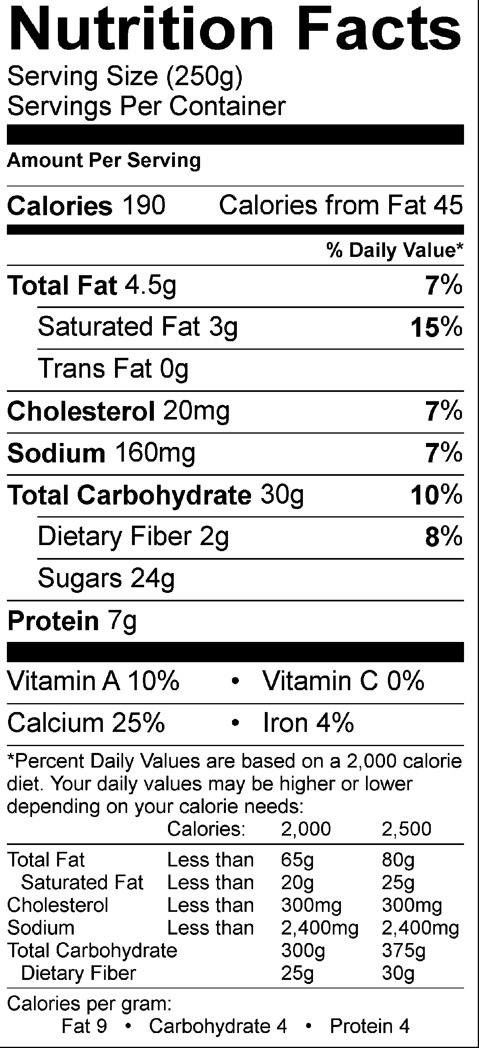

In fact, milk is part of the DAIRY food group.

Do you remember MYPLATE? You can see here that there are many kinds of dairy. Can you name these?

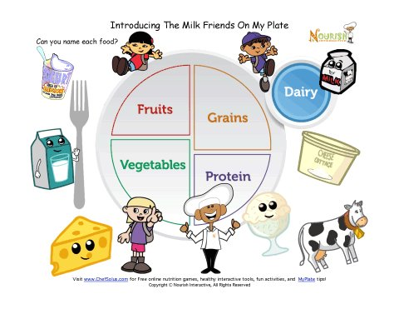Do you know how many foods or drinks you need in dairy each day? If you are 8 years old, you need about 2 and ½ servings/cups and if you’re 9 years old, you need

3 servings or cups.

source: http://www.choosemyplate.gov/food-groups/dairy-amount.html

BRAIN BREAK

OPTIONAL TASTING + ACTIVITY (10 minutes) MILK TASTE TEST AND MAKE AN AD

Now let’s have one serving – let’s taste some chocolate milk or white smilk (SNACK) and then you are going to get to practice making your own ads for milk.

Ask the students to try their milk and circle/color the face in their packet that relates to their opinion of the taste of milk.

Ask: is it delicious? How many of you circled the smily-est face? (could do a tally on the board) How many of you think it’s NOT delicious? (do a tally on the board).

Say: Ok, now let’s describe it. Remember that an adjective is a word used to describe an object. Please take another sip and try to describe milk. Milk is…

[There’s a sheet in the packet that allows the children to write 3 adjectives – this could be done individually or as a class ….some ideas: cold, yummy, smooth…could prompt them: it looks like…, it tastes like…it smells like…)

Say: Ok, now you can make your own ad. Let’s review. We said that advertising can offer information and try to get you to buy the product. Look at the facts and the words you used to describe it and the opinion of the class (point to the tally). You can now try to make your own ad.

[this activity could be done individually – you could let the students try their own ads for 5 minutes – then you could ask for students to volunteer their information or ideas and/or come up to the board and write/draw their ad. Alternatively, you could do this as a group activity where you ask the students for ideas. Some prompting questions may be: which fact(s) should we use (pointing to the nutrition facts)? Which of your adjectives or describing words should go in the ad? What pictures or characters should go in the ad? And then draw/write out the ad on the board].

Great job. Let’s take a picture of our ad to share with others (if you have a camera or smart phone you could take a photo to share with the researchers etc. ).

**Part II. Advertising Critique: Truth in Advertising (5-7 minutes). In this part of the lesson, you will convey to the students that food packages are another ‘kind’ of advertising and that advertising does not always show or tell the entire truth. Sometimes you have to ask questions and think about what is true. This is a critical thinking part.**

But you need to be careful with advertising. It might not tell you the whole truth. For example, the Got Milk advertisement didn’t tell you that there is added sugar. Ask: why not?

(answer: because then you or your mom may not want to buy it)

Here’s one other example. This is a cereal package. Is this advertising? Show the Cereal “All Berries” Example

[answer – kind of, it’s a form of persuasion. It gives you information, it promotes a point of view and it wants you to buy the product]

Ask: If you saw this package at the grocery, what would you think it is made of? What is inside this cereal?

(The students will probably (hopefully) say “Fruit.” Then you show them the ingredient label (it’s also in their packet))

Ask: How can you tell what is really inside the food?

(Remind them to look at the side or back of the package on the ingredient label. Show them that the first five ingredients – which tell you what is mostly in the food – does not list any kind of fruit. Tell them that sometimes advertising exaggerates or tries to show you visuals that are not always the complete truth. They need to be detectives to ‘decode’ the media)

**Part III. Advertising Around Us: Many Media Options (different kinds of advertising, media forms, media ubiquity) – 7-10 minutes. In this section you will ask them to think about all the places where they see advertising and you will introduce them to the traditional kinds of media (e.g., TV, radio, newspaper).**

Ask: We saw a print ad in a magazine (refer to Chocolate ad). We saw the cereal package. Where else do you find advertising?

(Ask the children where they have seen advertising today – at home or on their way to school. You could prompt them with questions such as: did anyone see TV today or hear radio? Did you pass any billboards or signs on the way to school? Did your parents read a newspaper or magazine? Can you remember any advertisements? As you are saying each different medium, you could hold up the appropriate “Media Card” and the Tape it to the Board)

Sometimes, there are other ways to tell you about a product or to persuade you. Where are other places where you see messages about products or names of products?

You could prompt them with questions such as: on the Internet – before they watch a Youtube video, when they are playing a computer game, on product packages, or even on clothing. You could ask the children to look around the room and see if they see any brand names /names of products on other people’s clothes, shoes, or backpacks (note: brand names even include sports teams).

There are many places where you see advertisements. Here are many places, can you name them? POWERPOINT SLIDE shows Bus, Radio, Billboards, TV, newspapers, movie theatres, magazines, computers, retail/stores …

Ask them: How many advertisements do you think you will see /come into contact with in a day?

(Encourage them to guess. Then tell them that no one really knows the exact answer, but it is probably between 500 and 1,000 ads. There is a lot of money spent on advertising. The money that companies spend to put advertising on TV or radio lets us see the shows for free.)

Ask them: What kinds of products do you think are advertised to kids the most? (or what kinds of advertising do they see?)

(Encourage them to guess. Then tell them that products advertised most often to kids include “sometimes” foods such as candy or fast food or toys. Tell them that we are going to use advertising to tell people about some healthier food just like in the milk ad.)

Review:

Today, we learned about what is advertising, what it is designed to do, and we examined closely this one ad. We also practiced making our own ad. Finally, we learned that advertising is all around us. We will learn more the next time.

**Lesson 4: Decoding Media: How and Why Advertising Works**

Overview

In this lesson, media makers will review concepts from Lesson 3. They will be asked to think about the persuasion process or why advertising ‘works’ and will be introduced to different types of advertising as a way to practice ‘decoding’ media messages. Students will also learn about media concepts such as “target audience” and “sponsor” and be introduced to some of the parts of a print ad (e.g., headline). Throughout the lesson, Common Core concepts related to main message, characters, and visuals will be reinforced. Nutrition content will be discussed as it relates to the food featured in the advertising (e.g., oranges).

Learning Objectives

Students will:

1. Learn media concepts of target ‘audience’ and message ‘sponsor’
2. Review/apply Common Core language principles of ‘main message, character, visuals’ to advertising messages
3. Practice de-coding messages, including examining different types of persuasive appeals
4. Think about how or why advertising ‘works’ (persuades people)
5. Be introduced to some the main parts of print advertising messages (e.g., headline, slogan)
6. Review nutrition information: oranges are part of the Fruit group. Know the different types of food in the Fruit group. Know the daily requirements of the Fruit group.
7. Practice writing different types of advertising – from fact/information to opinion claims. Create different images for the message.

Time Required:

Part I (20 minutes)

Brain Break (3-5 minutes)

Part II (5-7 minutes)

Part III (20 minutes)

Brain Break (3-5 minutes)

Part IV (10-15 minutes)

Materials:

1. student packet
2. powerpoint (optional)
3. advertising examples if not using powerpoint
4. crayons/markers/extra paper
5. snack options (carrots)

Common Core Standards:

1. [CCSS.ELA-Literacy.RL.3.1](http://www.corestandards.org/ELA-Literacy/RL/3/1/)  
   Ask and answer questions to demonstrate understanding of a text, referring explicitly to the text as the basis for the answers.
2. [CCSS.ELA-Literacy.RL.3.2](http://www.corestandards.org/ELA-Literacy/RL/3/2/)  
   Determine the central message, lesson, or moral and explain how it is conveyed through key details in the text.
3. [CCSS.ELA-Literacy.RL.3.3](http://www.corestandards.org/ELA-Literacy/RL/3/3/)

Describe characters in a story (e.g., their traits, motivations, or feelings) and explain how their actions contribute to the sequence of events.

4) [CCSS.ELA-Literacy.RL.3.6](http://www.corestandards.org/ELA-Literacy/RL/3/6/)  
Distinguish their own point of view from that of the narrator or those of the characters.

5) [CCSS.ELA-Literacy.RL.3.7](http://www.corestandards.org/ELA-Literacy/RL/3/7/)  
Explain how specific aspects of a text's illustrations contribute to what is conveyed by the words in a story (e.g., create mood, emphasize aspects of a character or setting)

**Part I. Decoding the Ad (about 20 minutes)**

**This section reviews opinions and facts in the advertising. It integrates ‘myplate’ nutrition concepts when discussing the product featured in the ad. Media concepts such as target audience and sponsor are introduced. Students practice identifying these concepts from the media messages.**

Remember last time we talked about advertising? Today we are going to look at a few more ads and you will be the detectives to figure out or decode what is happening and why the companies made the ads this way.

Let’s look at these ads: (oranges – on PPT)

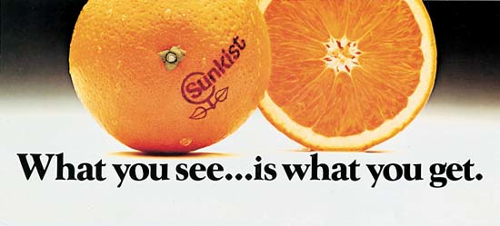

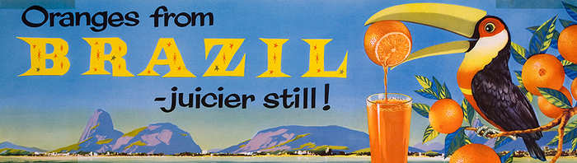

What are they advertising?

(note that these examples are in the student packet)

Please circle the OPINION in the ad.

Do you see any FACTS in the ads YES NO (not really …) no information.

Here is some information about the product (you’ll see in your packet – also on POWERPOINT) – here is the nutrition label.

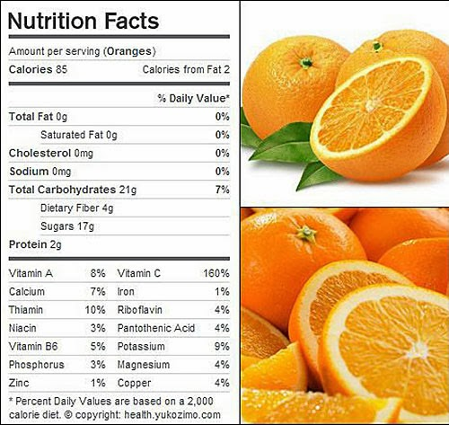

Which vitamin is there a lot of in oranges? (answer Vitamin C: more than your daily needs – 160%).

Remember myplate? (POWERPOINT and/or in the packet). Which food group is this product in?

(answer: fruit)

How much fruit is recommended for your age each day?

Answer: about 1 to 1 ½ cups

<http://www.choosemyplate.gov/printpages/MyPlateFoodGroups/Fruits/food-groups.fruits-amount.pdf>

Do you like oranges? What are some descriptive words for oranges?

Now we’re going to talk about some new words: audience and sponsor (point out where this is found in student packet).

An **Audience** (or **target audience**) is the people who receive the advertising message (can be a group such as “parents” or “girls”). These are the people the company wants to see the message.

Let’s play detective again and figure out the thinking behind this ad.

Here’s another ad: Tyson Chicken Nuggets – empty plate. Can someone read it for me?

(student reads)

This ad offers a big hint. Who do you think is the audience? Who is the ad for?

(answer: parents - POWERPOINT)

How do you know that?

Say: these big letters are called the headline – it says “to a parent, this is beautiful.” A headline attracts your attention.

In this case, the words: “to a parent” means the message is to a parent. Advertising does not always tell you the audience; sometimes you have to figure it out another way, like by looking at the picture.

Do you think this picture is beautiful?

(they’ll probably say no)

Why do you think a parent would think this was beautiful or like this picture?

(answer: because it means the child ate the food)

Sometimes different people may think different things or have different opinions about the same ad. Just like a book. The ideas and pictures may mean one thing to one person – like your parent – and something else to you. That is the same way with advertising. The pictures and the words are created for the target audience. You may have a different opinion than the author or creator of the ad and your parents may have a different opinion, too.

Let’s read the other words called “advertising copy”: Crispy on the outside, juicy on the inside and made with 100% all natural ingredients. Kids love them 100% of the time.

What is the main message here?

(answer – that they are yummy, the kids may say something or ask about all natural – and that kids love them – will eat them all the time).

What do you think about this last line (read: Kids love them 100% of the time). Do you think this is a fact or opinion?

This is tricky. It sounds like a fact. But do you think it could be true? Do you think everyone will love them all the time? Probably not. Sometimes it may not be true. Remember you need to be careful about some of the words in the advertising.

What if you picked a different audience? Let’s pick you, third grade students. How would you make an ad that you would like?

OPTIONAL ACTIVITY (depending on time and student interest, you could use this activity to brainstorm using a different picture, using different words, or generate ideas. The goal here is for the students to realize that advertising words /pictures may vary for the same product depending on the target audience).

What is the product they are selling?

(answer: chicken)

**Sponsor:**

Every ad must be paid for by the company or person sending the message – that is the sponsor. Usually the ad is paid for by the company who made the product.

A **Sponsor** is the person, company or organization that paid for the placement (media space) of an advertising message. If you’re a company like Minute Maid orange juice, you pay to put this ad in a magazine or an ad on the radio or television. That money helps pay for the radio station or the TV show.

Ask: Who is the sponsor of this message? Who paid for this message to be in a magazine?

(Answer: the chicken nugget company or Tyson. Try to get them to find or read the name of the sponsor/company. The packet asks them to circle the name.)

Which food group does chicken belong to?

(answer: Protein

http://www.choosemyplate.gov/food-groups/protein-foods.html

All foods made from meat, poultry, seafood, beans and peas, eggs, processed soy products, nuts, and seeds are considered part of the Protein Foods Group)

How much protein is recommended for your age each day?

(answer: 4 or 5 ounces)

<http://www.choosemyplate.gov/printpages/MyPlateFoodGroups/ProteinFoods/food-groups.protein-foods-amount.pdf>

But what does this mean? What counts as 1 ounce? (see chart = POWERPOINT)

<http://www.choosemyplate.gov/printpages/MyPlateFoodGroups/ProteinFoods/food-groups.protein-foods-counts.pdf>

BRAIN BREAK

**Part II. How Does Advertising Work? (about 5-7 minutes)**

**This is a short section to introduce the students to different psychological processes or ways that people think that advertising persuades us. It will help teach them to be critical thinkers of media as they try and work out how the company or organization is using writing or pictures to ‘sell.’**

Good. You guys are really doing great. Now we’re going to guess or figure out:

How Does Advertising Work?

Ask: How does advertising work?

(Some students may have some ideas.)

We don’t really know for sure. One idea called AIDA is that if you see the product and learn about– you will be interested in it – you will like it – and the more times you see the advertising, the more you will want it and buy it.

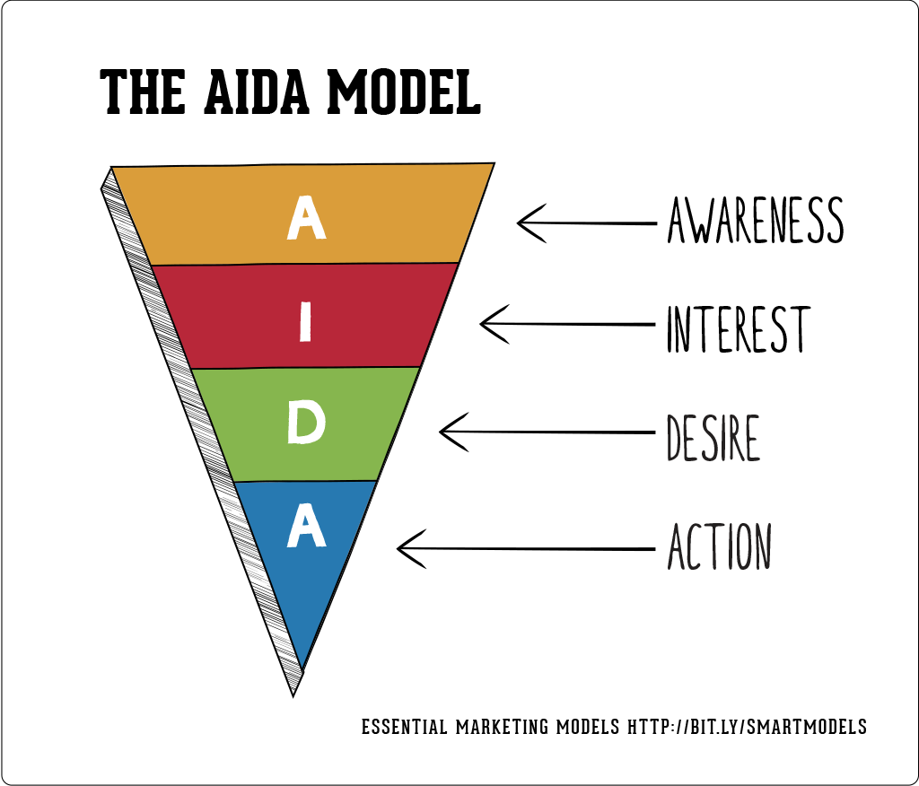

(You could draw this ‘model’ of advertising on the board if you want to or if you think it may be too complicated you could skip it. – also on POWERPOINT)

Say: Or maybe if you think the ad is funny – you’ll like the brand and the next time you’re shopping, you’ll ask your mom or dad or grandma for the product.

Say: Or maybe you will think a certain product is cool because the advertising makes you think its cool.

Show 2 advertising examples: Got Milk Halloween Snoopy Characters and Got Milk The Rock Saves the Day. On POWERPOINT

(Read them aloud – could also tack/tape them on the wall or blackboard).

Ask: which advertisements do you like more? Which one appeals to you? Why? Invite a volunteer to come to the class and “vote” /point to their favorite ad.

Say: if you like this ad, the company wants to you to ask your parents for the product or encourage you to buy. That is the purpose of advertising.

[if time allows you could have them practice writing/stating their opinion in the space in their packet)

**PART III. Different Types of Persuasive Appeals (about 20 minutes)**

**In this section you will introduce different types of persuasive appeals used in advertising, review key concepts, allow students to ‘practice’ creating advertising ideas.**

**Types of Persuasive Appeals**

Say: Advertising uses different ways to inform and persuade you about a product or service.

We are going to look at some different ways and then you get to practice making a print ad, okay?

1. CHARACTERS

(Show General Mills cereal characters ad and read it aloud, on POWERPOINT)

Ask: What is the main message in this ad? How do they convey/tell you about the message?

(Answer: Yes, they use special characters)

Ask: which characters do you see?

(answer: It looks like the Trix bunny, the Lucky Charms leprechaun and the Cocoa Puffs bird. If the target audience for the ad is children, the company may try to use characters that they know that children will know and like. They think that if you like the character, you will like the product. )

Do you like the characters?

(answer: ?? if they say yes, then you can tell them that the “ad is working”…)

1. CELEBRITY – FAMOUS PEOPLE

Show Pepsi Lionel Messi Ad and Got Milk – the Rock ads - POWERPOINT

Ask: Do you recognize the people in these ads?

(Answer: This one is Lionel Messi; he is a famous soccer player. )

How do you think he feels in this ad?

(answer: happy, excited, ?)

What makes you think that?

(answer: he’s smiling..?)

How do you think he feels about Pepsi?

(answer: he likes it).

He probably does like it. He also gets paid millions of dollars to be in these advertisements.

Why do you think Pepsi put Lionel Messi in this ad?

(answer: because many people like him, and they will like the ad or they think he’s cool and they will want to drink Pepsi, too. Maybe they think Pepsi will help them to play soccer like Messi).

(source: about Messi:

http://en.wikipedia.org/wiki/Lionel_Messi

<http://www.espnfc.com/player/_/id/45843/lionel-messi?cc=5901>)

But is Pepsi part of the MYPLATE FOOD GROUPS?

(no)

Let’s look at the Nutritional Facts about Pepsi.

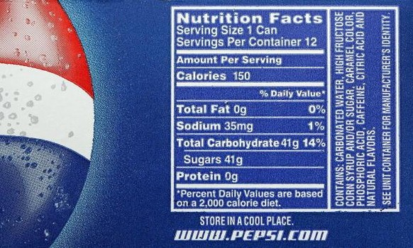

Look at the label – how much sugar? 41 g – that’s a lot. Is there any vitamins? (no) Protein? (no)

Do you think it will help this soccer player be stronger? Will it give him the nutrients he needs to play soccer? (no)

What about this ad? (point to the Got Milk ad)

Who is this?

(Answer: He is best known as “The Rock” – his name is Dwyane Johnson. He was a famous wrestler and now he is in movies. about “The Rock” <http://en.wikipedia.org/wiki/Dwayne_Johnson>)

What do you think he is doing and feeling in this ad?

(Answer: he is helping rescue the cat, he is looking strong)

Read it aloud: “Protein to save the day. 8 grams in every 8 oz. glass”

How does the picture of The Rock help us to believe these words? What is the message here?

(Answer: he looks strong and protein can help you be strong, too).

Do you see these words? (point to and read “Got Milk?”)

That is called the slogan. A slogan is a short phrase or a few words used in advertising for a certain brand or product (e.g., “Milk – It Does a Body Good”). It tells you something about the brand and helps you to remember the ad.

1. EXAGGERATION

Show Eggo Parade the Waffle ad and read it aloud.(POWERPOINT)

Ask: What is the main message in this ad? How do they show or tell you about the message?

Answer: Sometimes advertising goes over-the-top or uses exaggeration. This means that the picture or the words may not be actually true, but they are used to get your attention and try to get you to think something.

Ask: What do you think this picture is trying to say?

Here’s another one that uses this same technique. Show Country Crock Veggies ad.

What are they advertising?

(answer: the kids may say veggies – but it is actually for margarine/butter – the ad is telling them with margarine the veggies will get eaten up fast)

(note there are 2 questions about advertising technique and target audience under each ad. The students can fill it out on their own or you can ask them in class).

1. PRODUCT AS HERO

Here’s our last ad for today. POWERPOINT

(Show Welch’s grape juice – plump, juicy, delicious ad and read it aloud)

Ask: What is the main message in this ad? How do they convey/tell you about the message?

This ad shows a big visual. In this ad, there are no famous people or characters, the food or product is the hero. For food advertising, a special photographer is used to make the food look really really yummy. Can you see how they zoomed in on the grapes and made them look very big and very fresh? Now, let’s read the word, “Plump, Juicy, Delicious.” These are adjectives or describing words. POWERPOINT

In this case the picture/visual and the words go together great.

What about grape juice? Do we think it is a healthy food?

(answer: yes and no)

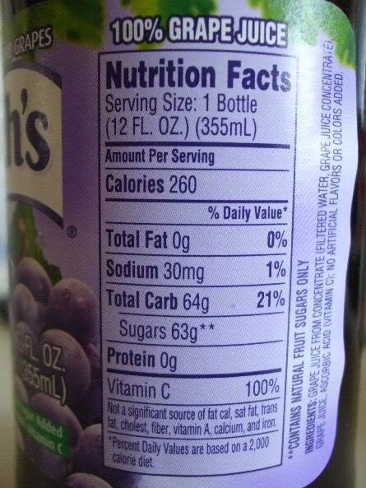 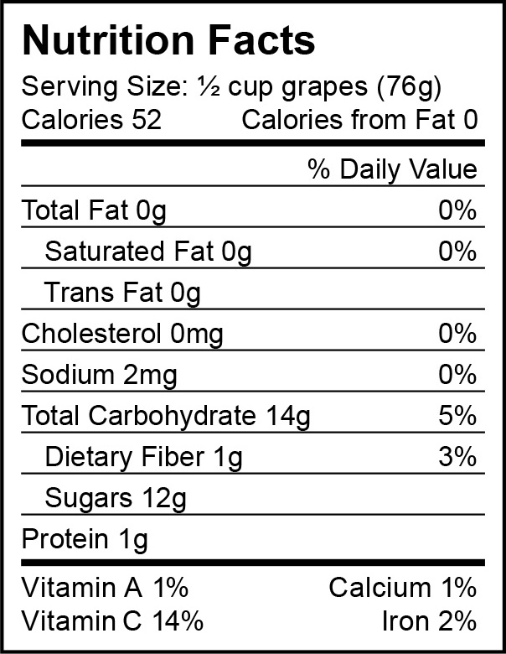

Nutritional facts – grape juice – how many grapes are in there?

Ingredients says grape juice from concentrate – it has 100% of Vitamin C, which is great, but it also has 63 g of sugar, that’s a lot of sugar. It would be better to eat grapes than drink the juice.

BRAIN BREAK

**Part IV. ACTIVITY: APPLY WHAT YOU LEARN (10-15 minutes)**

**There is space for this activity in the children’s packet. It allows them to practice /apply what they learned.**

Optional (snack: carrots)

Let’s try out our new techniques. Let’s think of advertising for a carrot.

A carrot is part of which food group?

(Answer it is a vegetable)

<http://www.choosemyplate.gov/food-groups/vegetables.html>

How much vegetables should your age group have each day?

(answer: about 1 ½ to 2 cups)

<http://www.choosemyplate.gov/printpages/MyPlateFoodGroups/Vegetables/food-groups.vegetables-amount.pdf>

So we want children to eat vegetables to make their body strong. How can we make advertising for a carrot?

How can we use a character to sell a carrot?

Can anyone draw a character?

How can we use a famous person?

Who could we use in our ad? (why?)

How can we make a funny or exaggerated picture?

What are some words to describe a carrot? (adjectives)

What is an informative claim or fact about carrots? (answer – look to the nutrition facts label)

How can we draw a carrot to make it look really yummy?

(show POWERPOINT pictures of real-life carrot package – Frozen MOVIE)

Packages are another kind of advertising. These carrot packages showed the princess from the movie FROZEN. There is a special deal if you buy the carrots, you can get a coupon for the movie. This type of promotion encourages people to buy the product.

Great job.

**Lesson 5: Advertising Process and Research**

Overview

In this lesson, media makers are introduced to how advertising and other media messages are made, including “public service advertising.” They will also begin the very first step of the process: learning how to conduct research: both secondary research (e.g., finding and analyzing existing information sources) and primary research (conducting a survey /asking questions). As part of the research, they will review how to find /evaluate sources for research and review/apply concepts from Math Common Core curriculum related to measurement (bar graphs). In this lesson, students will also learn more about their featured “product” for the advertising campaign – broccoli and review principles for target audience.

Learning Objectives

Students will:

1. Gain awareness of the process of how to create media /advertising messages.
2. Be introduced to the concept of “public service advertising”
3. Understand the kinds of research that are conducted; be introduced to concepts of secondary and primary research.
4. Practice conducting and analyzing research
5. Review/apply Common Core mathematic principles related to measurement and data (bar graphs)
6. Review 60-minute daily exercise guideline as part of public service campaign targeting youth

Time Required:

Part I (15 minutes)

Brain Break (3-5 minutes)

Part II (20 minutes)

Brain Break (3-5 minutes)

Part III (7-10 minutes)

Materials:

1. Student Packet
2. Powerpoint (optional)
3. Ads or visuals if not using powerpoint
4. Art supplies: crayons or markers/extra paper
5. Snack (optional): broccoli
6. Optional: Any supplemental materials (library?) on broccoli

Common Core Standards

1. Math: Measurement and Data

Represent and interpret data.

MD.3 Draw a scaled picture graph and a scaled bar graph to represent a data set with several categories. Solve one- and two-step "how many more" and "how many less" problems using information presented in scaled bar graphs.

2. Writing standards:

Conduct short research projects that build knowledge about a topic.

Recall information from experiences or gather information from print and digital sources; take brief notes on sources and sort evidence into provided categories.

**PART I. THE ADVERTISING PROCESS (about 15 minutes).** **In this introductory session, the students will be introduced to the process by which advertising and other media messages are made. They should understand that it usually takes more than one person to make an ad and there is much research, planning and creativity involved. The students will then follow all of these steps for their final project (in an accelerated fashion☺) .**

Today we are going to learn about how advertising and media messages are made. Does anyone have any ideas?

(they may say a number of things here – the focus is usually on creating – there is usually not much knowledge about the background research or thinking).

Well, a lot of people usually make an advertising or media message. This graphic and the summary of 5 steps below are in the student packet. POWERPOINT



It takes many people and many steps to make an advertisement or media message: (1) **research** /find information about product/people (audience)

(2) making a **plan:** thinking about the best way to organize the information

(3) **brainstorming:** thinking of many ideas for words and pictures

(4) **creativity:** practicing making creative ideas (words, pictures) that fit the plan

(5) **research:** make sure the audience will like the ad ideas

Advertising Example: DISCOVER THE FOREST

This is an example of an outdoor ad or billboard. (this ad and the question are in the student packet)

What is the main message?

1. that you should buy a tree;
2. that children may be curious and learn in the forest - ANSWER
3. that children are bored in the forest
4. that you should buy a flower blossom

How do you know that?

(answer the girl is smiling, the headline reads: where curiosity blossoms and the Discover the Forest.org)

Who is the sponsor?



This is a special type of advertising called **Public Service Advertising**. Instead of advertising a product to buy, it is advertising something that is good for the public – like visiting the forest, recycling, or being careful with matches so you don’t start a fire. The sponsor is the Forest Service Department of Agriculture. The Advertising Council is a special organization/group that helps make these kind of messages. Usually, they do not need to pay to be on TV or on a billboard because they are this special kind of advertising. Sometimes people who make advertising work at an **Advertising Agency.** They create these kinds of advertising for free.

How did they make this ad?

They first did some research. They found out that:

**88% of kids today say they like being in nature, and 79% wish they could spend more time there.**

How many of you like being in nature? (the woods)? How many of you wish you could spend more time there?

Next they found that: Research shows there are many benefits to kids spending time in nature. This time spent outdoors gives children the ability to explore, use their imaginations, discover new wildlife and engage in unstructured and adventurous play.

This campaign seeks to raise awareness of these benefits, inspiring young people to discover the joy of exploring the natural world, and encouraging families to experience nature first-hand.

Source: <http://www.adcouncil.org/Our-Work/Current-Work/Family-Community/Discovering-Nature>

Does this ad make you want to visit nature?

(answer will vary. If no, ask them: What would help you to want to visit nature? If time allows).

OPTIONAL – NEEDS POWERPOINT: Public service advertising can use other media, too. Like TV or radio. Here’s a TV commercial.

Do you recognize the characters? (From movie Rio 2). Do you like this ad?

(Another thing you could point out: on the website – they have different ‘versions’ for target audiences – it’s interesting that it’s even labeled: general market, Spanish language, African American. You could play the different versions and ask the students which audience it is for. This may be especially good for a diverse student body in your classroom for them to see ‘themselves’ in the advertising. Research shows most ads feature Caucasians in the USA).

Remember that it is recommended that you do some form of physical activity every day for up to 60 minutes – that is 1 hour. Hiking or walking in the woods is an example of a physical activity. Source: <http://www.choosemyplate.gov/physical-activity/amount.html>

[then you got back to explain the advertising process:]

After they did this research, then they thought about the target audience: children like you. Then they thought of many many ideas and tried to figure out what the main message should be. Then, when they agreed on one idea, they made a plan or an outline of what they wanted. They wrote it down on a paper called a brief. Next the creative team – usually someone does the art or the video and the other person is the writer – got together and doodled and wrote down all kinds of ideas – maybe 200 ideas. After that, maybe they asked children what they thought of the ideas – or maybe the sponsor picked the best idea. And then, they actually started making the ad.

This is kind of what we’re going to do – in a small way – in this class. We’re going to do some research, think about the target audience, make a plan and create lots of ideas for art and words about our product.

BRAIN BREAK

**PART II. Research (about 20 minutes).**

**This section will review and/or introduce primary and secondary research – mainly about broccoli and a little about the target audience: third-grade students.**

**Step 1: Research**

The first thing media people do is the same as when you do any new project – you do your research.

What kind of research have we done so far in this class?

(this depends on the class projects – you could remind them of a science project or other project where the students needed to gather/analyze information and write about it).

Today we are going to do some research about our PRODUCT: broccoli (target vegetable/fruit) and our AUDIENCE: third-grade students.

Where might we find information about this food?

(answer: will vary - farmers, books, food labels, websites, grocery store)

We could find information that already exists in books or websites. This is called **secondary research information**.

How or where could we search for information?

(answer on the Internet> We could search for broccoli - )

How do we know that?

We also want to know information about how people feel about the product and we want to know about it ourselves. So in this case we want to try it and we want to ask other people about it. This information does not already exist, we need to find and collect the information ourselves. This is called **primary research.**

PPT slides show secondary research info (also in packet):

1. “Broccoli is a hardy vegetable of the cabbage family that is high in vitamins A and D. It develops best during cool seasons of the year.”

2. 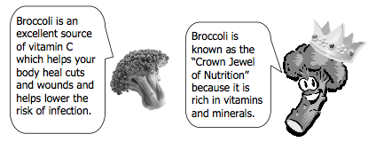

3. Food label:

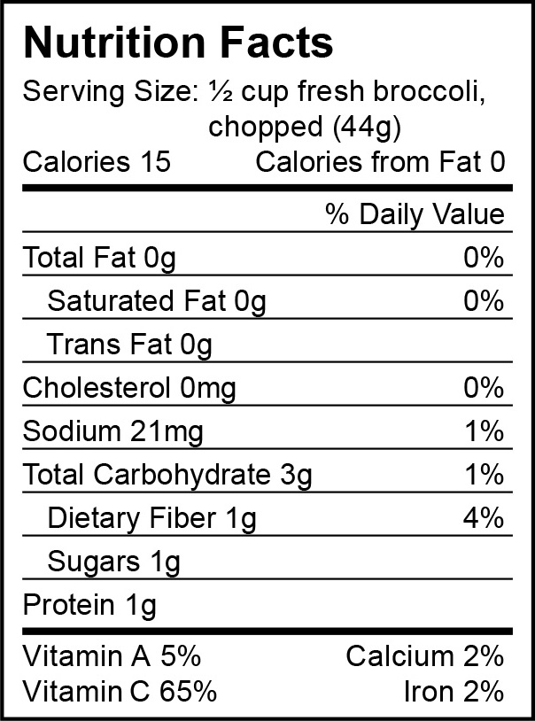

Another way we can do research about food is to check the labels. Here is a label – nutrition facts for broccoli. What do you notice about it?

What does it NOT have in it? (fat)

What does it have only a little of? (protein, sugars)

What does it have a lot of? (Vitamin C)

Let’s do some primary research.

Sometimes when you want to find out information, you ask people. Since you are the target audience for broccoli, I’m going to ask you some questions. (POWERPOINT)

|  |  |  |  |
| --- | --- | --- | --- |
|  | **YES** | **NO** | **Total** |
| Have you tried broccoli? |  |  |  |
| Do you like broccoli? |  |  |  |
| Does your family buy broccoli? |  |  |  |
| Do your friends like broccoli? |  |  |  |

(you could ask them to stand up or raise their hand for “YES” and do a tally)

How could we make a bar graph to show that information?

(there’s an example bar chart in the student packet –and POWERPOINT you could refer to that one and/or draw one for the tally data on the chalk board) .

OPTIONAL: Good – now we’re going to review bar graphs – you get to practice (if time allows) – there is a worksheet in the packet: Reading a Bar Graph: FAVORITE VEGGIES: PRACTICE Go over this sheet or skip it and go on with primary research

OPTIONAL: TASTE TEST. Bring in/have broccoli from cafeteria (?) – could encourage the students to try and it also ‘pair’ it with other dips such as hummus, ranch dressing or lemon on top.

DESCRIBING/BRAINSTORMING

The POWERPOINT and student packet has several forms to get the students to think about ways to use the senses/adjectives to describe vegetables.

You could also encourage free association – other ways to think about it.

Other ways you could do primary research about broccoli

* Go to the grocery store and see how people are shopping in the produce (vegetable) section
* Watch people eating broccoli (or other vegetables) in the cafeteria
* Ask people questions about broccoli
* Try recipes and do a ‘taste test’

BRAIN BREAK

**Part III. Target Audience (about 7-10 minutes). This section applies ‘research ideas’ to the concept of the audience for the message. They need to think about themselves. There are places in the student packet for them to fill in the blanks if time for the questions posed below.**

When you are creating messages, you need to know about the target audience (the people you want to see your message). You should know what they like to do – what they believe in – and their behavior with respect to the product. In our case, we’re interested in food – so we want to know how and what and why they eat certain foods.

We could learn about our audience the same way that we learned about broccoli – by finding information and by asking questions.

**What do they like to do?**

**What do they like to eat?**

**How can we convince them to eat broccoli?**

Review – Advertising Process

Today we learned a little about advertising is made and we did this first step – research. Research means finding out information about the product and the target audience. Next time we will write the strategy/plan – think of ideas – and actually write and create our ads. Remember, usually it takes a team effort. Some people do the research, some people do the plan, other people do the writing and other people make the art. We are doing all of these steps in this class.

**Lesson 6: Advertising Message Strategy and Creativity**

Overview

In this lesson, media makers will review the process by which advertising and other media messages are made. They will review/integrate their ‘research’, practice the strategy (“making a plan”) and creative steps in the process. Students will brainstorm creative ideas – based on their plan – and work toward writing and producing images for their print advertisement for broccoli. They can also practice Common Core collaboration, communication, and presentation skills in small and large group settings.

Learning Objectives

Students will:

1. Review the process of how to create media /advertising messages.
2. Think about target audience
3. Integrate research ideas into written language
4. Practice creativity through visual ideas
5. Learn how to explain /present their ideas
6. Review Common Core speaking and listening principles related to asking questions, staying on topic, and linking their comments to the remarks of others

Time Required:

Part I (10 minutes)

Brain Break (3-5 minutes)

Part II (about 20 minutes)

Brain Break (3-5 minutes)

Part III (30 minutes)

Materials:

1. Student Packet
2. Powerpoint
3. Advertising or visuals if not using Powerpoint
4. Art supplies: crayons or markers
5. Extra paper for the final advertisements: we would like to collect them and feature them on a website (Illinois Extension and/or Illinois – Advertising department).

Common Core Standards

Speaking and Listening standards:

Comprehension and Collaboration:

1. Engage effectively in a range of collaborative discussions (one-on-one, in groups, and teacher- led) with diverse partners on grade 3 topics and texts, building on others’ ideas and expressing their own clearly.

a. Come to discussions prepared, having read or studied required material; explicitly draw on that preparation and other information known about the topic to explore ideas under discussion.

b. Follow agreed-upon rules for discussions (e.g., gaining the floor in respectful ways, listening to others with care, speaking one at a time about the topics and texts under discussion).

c. Ask questions to check understanding of information presented, stay on topic, and link their comments to the remarks of others.

d. Explain their own ideas and understanding in light of the discussion.

2. Determine the main ideas and supporting details of a text read aloud or information presented in diverse media and formats, including visually, quantitatively, and orally.

3. Ask and answer questions about information from a speaker, offering appropriate elaboration and detail.

**PART I. Review of Advertising Process and Integrate Research (about 10 minutes)**. **In this first part of the lesson, you will review the advertising process and the research collected so far and ask the students to start integrating what they know. You could put them into smaller groups or do the lesson as a whole class. Ideally, the students can learn to communicate/collaborate to come to some kind of consensus.**

Let’s review: so far we learned about how advertising is made, we learned about different ways to do advertising and we did some research about broccoli and our target audience. Today we are going to think of a plan – think creativity and come up with many ideas and then do some writing and some art for our advertising.

What do we know about BROCCOLI? Let’s think back to our research.

- nutrition?

- adjectives?

- do children like?



Let’s think about our TARGET AUDIENCE for this food product: third-grade students.

(Here – you could get them to describe the ‘lifestyles’ information – third-graders like to play, they like funny things, they like playing video games and sports and doing art and dancing doing Rainbow Loom and watching the Lego Movie and Frozen and Fineas and Ferb (or whatever the latest and greatest is!)

For food, they usually eat their lunch at school. They often try new foods if their friends do (or whatever).

Some people – but not everyone – likes broccoli (or whatever your class survey revealed))

After our break, we are going to make a plan for our advertising. The plan is called a strategy.

BRAIN BREAK

**PART II. Strategy or Plan (about 20 minutes) In this part of the lesson, students will review the parts of a print advertisement since that is what they will be creating in this pilot lesson curriculum. Then, they will learn about a ‘brief’/creative brief, which is a document that advertising people use to form a strategy for their advertising. They will also start brainstorming ideas. This can be done in small groups or for time/efficiency can also be done as a class activity.**

Parts of a Print Advertisement

We are going to make a plan and then actually create our own print advertisements for broccoli to encourage other children to try it. POWERPOINT: This is an example of a print advertisement. This one is for DelMonte Peaches. It was in a magazine. Print advertising can be in magazines or newspapers.

You can see the brand name, the product name – the visual or picture and the slogan. The slogan “Bursting with Life” is a short phrase to get you to think about the product in a certain way.

Here is another one for a smoothie (V8 SMOOTHIE) – POWERPOINT

Here is another print ad in a magazine. This one is for a smoothie. You can see the picture. The headline – (“So good it blows the lid off your regular smoothie”) is to attract your attention. There are words on the page that tell you about the product – this is called “copy” or body copy”. You’ll also find a slogan and brand name.

We are going to make something like this for broccoli using pictures, a headline and words.

Let’s Make a Plan for our Broccoli Advertising: CREATIVE BRIEF: the “plan” or set of instructions to follow when making the ad.

Our Product is: ____________________________________________

Our Brand Name is: _______________________________________(They can make up a brandname – maybe your name???

Some information or facts we know about it: Source of Information:

Some opinions about it:

Our audience for the ad is: ___________________________________

Right now, this is what they know or think or feel about the product:

This is how we want them to think or feel:

We would like to use these adjectives or other words or “body copy” in our ad:

We would like to use these visuals and/or characters in our ad (you can draw or describe):

The main message will be:

We would like to use this headline or this slogan:

BRAIN BREAK

**PART III. Let’s Get Creative - Creativity (about 30 minutes) In this part of the lesson, the students will get to brainstorm or think of a lot of different ideas for their broccoli advertising. Your job is to guide /elicit their creativity – both in pictures and words. Ideally, the words and pictures go with the plan/brief – and can integrate some of the previous work (e.g., nutrition content, adjectives, opinions, etc). But maybe it’s also better if they can generate a lot of ideas first – then you can help them to channel their ideas into the “best” 2 or 3 ideas. As an individual, small group and/or class, you should be able to finish some examples of print advertisements for broccoli. Note that these can be ‘roughs’ – drafts – this is the way it is done in real advertising agencies. Please save/scan in/take photos of your advertisements and/or brainstorming so that we can feature these materials on the Illinois Extension and/or Illinois Advertising Department web site. Don’t worry if they are ‘rough’ – it would be neat to see the facets of the brainstorming process – pictures or examples of ‘many ideas’ – the best ideas – and the plan along with the final ads.**

Brainstorming: Now we are going to do some Brainstorming. Brainstorming is when you think of lots of ideas as a group. This is fun – let’s get started!

Before we start, here are some ground rules:

* One idea at a time
* Encourage wild & crazy ideas
* Go for quantity – as many as you can!
* Be visual
* Be positive
* Build on others’ ideas – “yes” – “and….”

(Brainstorming ideas/questions to get the conversation going:)

* What is fun /funny about Broccoli?
* What do you think a Broccoli character would look like?
* What would a broccoli character say?
* What would a broccoli character wear?
* What would a broccoli character sing or play?
* What would a broccoli character do?

What if broccoli was

…. a pet?

….a superhero?

….an alien?

….a princess?

….a third-grade student?

…a car?

POWERPOINT: )Next you can show them a few other examples of funny ads or pictures related to broccoli as another way to spark their imagination. You can also bring in real broccoli if you wish or print out pictures of broccoli.)

Layout: Design

After thinking about the words, the art director or creative person in the advertising agency thinks about how to design the ad – or where to put the pictures, the headline, the words. Let’s sketch some different layouts or ads.

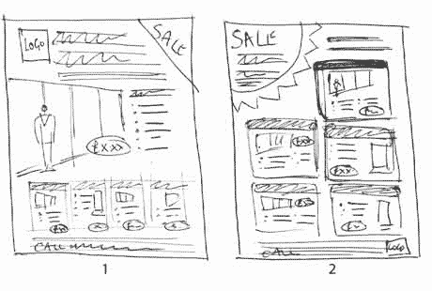

Let’s spend some time now writing our ads. (This can be done as an individual activity, in small groups or as a class. Ideally, there will be some print advertising to show/share. )

(After they create the ads – OPTIONAL – you could review the ‘plans’ or Creative Briefs and see whether the PLAN and the ADS match. ) (Review the advertising process from Lesson 5.)

We have done a great job in this unit. We learned about healthy food – and how advertising is made. We did some extra research about broccoli. We made a plan and we created some great advertising for broccoli. Maybe we can see more advertising for healthy food.

We will see our broccoli ads on a website. Nice job!