Lesson 4: Decoding Media: How and Why Advertising Works

Overview
In this lesson, media makers will review concepts from Lesson 3. They will be asked to think about the persuasion process or why advertising ‘works’ and will be introduced to different types of advertising as a way to practice ‘decoding’ media messages. Students will also learn about media concepts such as “target audience” and “sponsor” and be introduced to some of the parts of a print ad (e.g., headline). Throughout the lesson, Common Core concepts related to main message, characters, and visuals will be reinforced. Nutrition content will be discussed as it relates to the food featured in the advertising (e.g., oranges).

Learning Objectives
Students will:
- Learn media concepts of target ‘audience’ and message ‘sponsor’
- Review/apply Common Core language principles of ‘main message, character, visuals’ to advertising messages
- Practice de-coding messages, including examining different types of persuasive appeals
- Think about how or why advertising ‘works’ (persuades people)
- Be introduced to some the main parts of print advertising messages (e.g., headline, slogan)
- Review nutrition information: oranges are part of the Fruit group. Know the different types of food in the Fruit group. Know the daily requirements of the Fruit group.
- Practice writing different types of advertising – from fact/information to opinion claims. Create different images for the message.

Time Required:
Part I (20 minutes)
Brain Break (3-5 minutes)
Part II (5-7 minutes)
Part III (20 minutes)
Brain Break (3-5 minutes)
Part IV (10-15 minutes)

Materials:
- student packet
- powerpoint (optional)
- advertising examples if not using powerpoint
- crayons/markers/extra paper
- snack options (carrots)

Common Core Standards:
- CCSS.ELA-Literacy.RL.3.1
Ask and answer questions to demonstrate understanding of a text, referring explicitly to the text as the basis for the answers.
- CCSS.ELA-Literacy.RL.3.2
Determine the central message, lesson, or moral and explain how it is conveyed through key details in the text.
- CCSS.ELA-Literacy.RL.3.3
Describe characters in a story (e.g., their traits, motivations, or feelings) and explain how their actions contribute to the sequence of events.
4) CCSS.ELA-Literacy.RL.3.6
Distinguish their own point of view from that of the narrator or those of the characters.
5) CCSS.ELA-Literacy.RL.3.7
Explain how specific aspects of a text's illustrations contribute to what is conveyed by the words in a story (e.g., create mood, emphasize aspects of a character or setting)

Part I. Decoding the Ad (about 20 minutes)
This section reviews opinions and facts in the advertising. It integrates ‘myplate’ nutrition concepts when discussing the product featured in the ad. Media concepts such as target audience and sponsor are introduced. Students practice identifying these concepts from the media messages.

Remember last time we talked about advertising? Today we are going to look at a few more ads and you will be the detectives to figure out or decode what is happening and why the companies made the ads this way.

Let’s look at these ads: (oranges – on PPT)

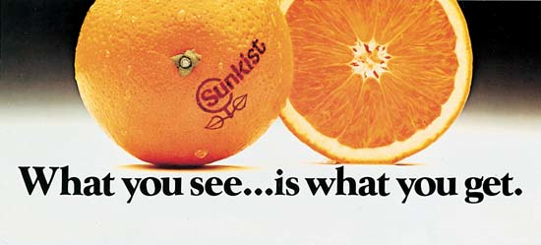

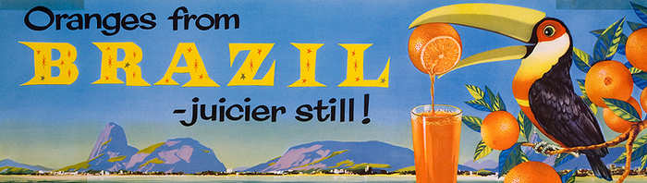
What are they advertising?

(note that these examples are in the student packet)

Please circle the OPINION in the ad.
Do you see any FACTS in the ads YES NO (not really …) no information.
Here is some information about the product (you’ll see in your packet – also on POWERPOINT) – here is the nutrition label.
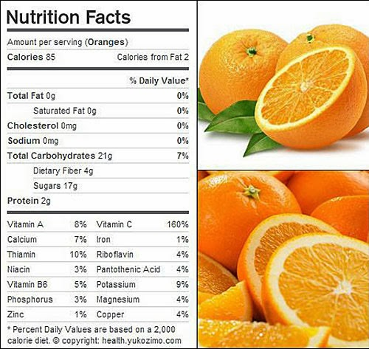

Which vitamin is there a lot of in oranges? (answer Vitamin C: more than your daily needs – 160%).

Remember myplate? (POWERPOINT and/or in the packet). Which food group is this product in?

(answer: fruit)

How much fruit is recommended for your age each day?

Answer: about 1 to 1 ½ cups
http://www.choosemyplate.gov/printpages/MyPlateFoodGroups/Fruits/food-groups.fruits-amount.pdf

Do you like oranges? What are some descriptive words for oranges?

Now we’re going to talk about some new words: audience and sponsor (point out where this is found in student packet).

An Audience (or target audience) is the people who receive the advertising message (can be a group such as “parents” or “girls”). These are the people the company wants to see the message.

Let’s play detective again and figure out the thinking behind this ad.

Here’s another ad: Tyson Chicken Nuggets – empty plate. Can someone read it for me?

(student reads)

This ad offers a big hint. Who do you think is the audience? Who is the ad for?

(answer: parents - POWERPOINT)

How do you know that?

Say: these big letters are called the headline – it says “to a parent, this is beautiful.” A headline attracts your attention.

In this case, the words: “to a parent” means the message is to a parent. Advertising does not always tell you the audience; sometimes you have to figure it out another way, like by looking at the picture.

Do you think this picture is beautiful?

(they’ll probably say no)

Why do you think a parent would think this was beautiful or like this picture?

(answer: because it means the child ate the food)

Sometimes different people may think different things or have different opinions about the same ad. Just like a book. The ideas and pictures may mean one thing to one person – like your parent – and something else to you. That is the same way with advertising. The pictures and the words are created for the target audience. You may have a different opinion than the author or creator of the ad and your parents may have a different opinion, too.

Let’s read the other words called “advertising copy”: Crispy on the outside, juicy on the inside and made with 100% all natural ingredients. Kids love them 100% of the time.

What is the main message here?

(answer – that they are yummy, the kids may say something or ask about all natural – and that kids love them – will eat them all the time).

What do you think about this last line (read: Kids love them 100% of the time). Do you think this is a fact or opinion?

This is tricky. It sounds like a fact. But do you think it could be true? Do you think everyone will love them all the time? Probably not. Sometimes it may not be true. Remember you need to be careful about some of the words in the advertising.

What if you picked a different audience? Let’s pick you, third grade students. How would you make an ad that you would like?

OPTIONAL ACTIVITY (depending on time and student interest, you could use this activity to brainstorm using a different picture, using different words, or generate ideas. The goal here is for the students to realize that advertising words /pictures may vary for the same product depending on the target audience).
What is the product they are selling?

(answer: chicken)

Sponsor:
Every ad must be paid for by the company or person sending the message – that is the sponsor. Usually the ad is paid for by the company who made the product.

A Sponsor is the person, company or organization that paid for the placement (media space) of an advertising message. If you’re a company like Minute Maid orange juice, you pay to put this ad in a magazine or an ad on the radio or television. That money helps pay for the radio station or the TV show.

Ask: Who is the sponsor of this message? Who paid for this message to be in a magazine?

(Answer: the chicken nugget company or Tyson. Try to get them to find or read the name of the sponsor/company. The packet asks them to circle the name.)

Which food group does chicken belong to?

(answer: Protein
http://www.choosemyplate.gov/food-groups/protein-foods.html
All foods made from meat, poultry, seafood, beans and peas, eggs, processed soy products, nuts, and seeds are considered part of the Protein Foods Group)

How much protein is recommended for your age each day?
(answer: 4 or 5 ounces)
http://www.choosemyplate.gov/printpages/MyPlateFoodGroups/ProteinFoods/food-groups.protein-foods-amount.pdf

But what does this mean? What counts as 1 ounce? (see chart = POWERPOINT)
http://www.choosemyplate.gov/printpages/MyPlateFoodGroups/ProteinFoods/food-groups.protein-foods-counts.pdf

BRAIN BREAK

Part II. How Does Advertising Work? (about 5-7 minutes)
This is a short section to introduce the students to different psychological processes or ways that people think that advertising persuades us. It will help teach them to be critical thinkers of media as they try and work out how the company or organization is using writing or pictures to ‘sell.’

Good. You guys are really doing great. Now we’re going to guess or figure out:
How Does Advertising Work?

Ask: How does advertising work?

(Some students may have some ideas.)

We don’t really know for sure. One idea called AIDA is that if you see the product and learn about– you will be interested in it – you will like it – and the more times you see the advertising, the more you will want it and buy it.

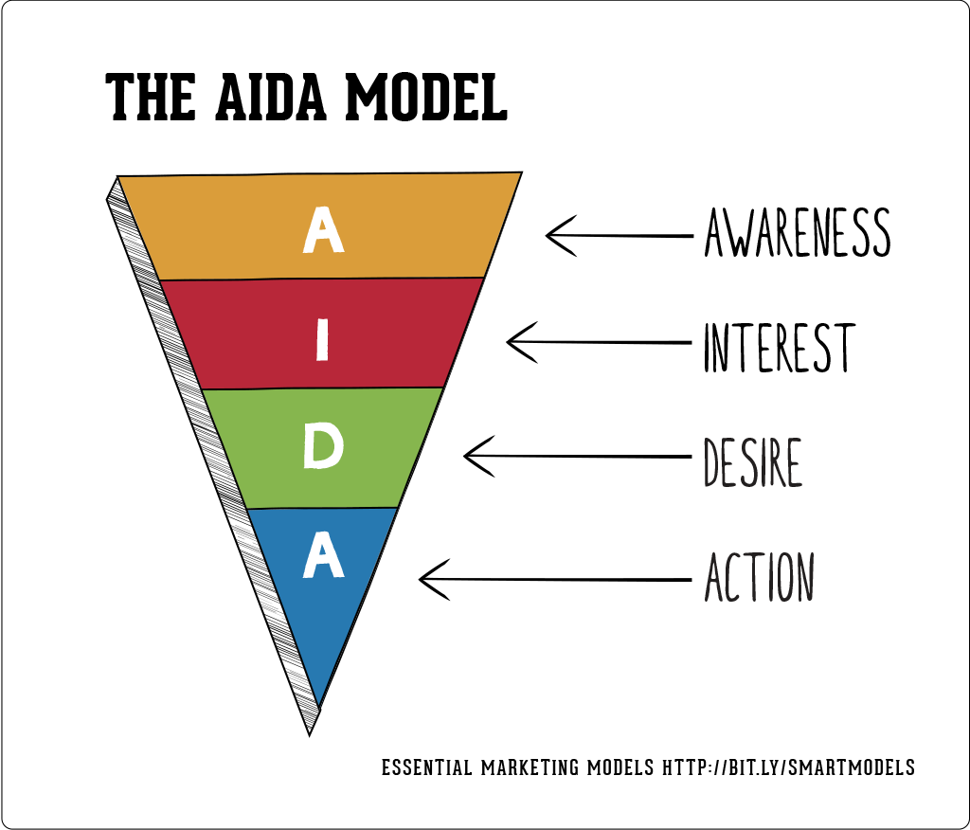

(You could draw this ‘model’ of advertising on the board if you want to or if you think it may be too complicated you could skip it. – also on POWERPOINT)

Say: Or maybe if you think the ad is funny – you’ll like the brand and the next time you’re shopping, you’ll ask your mom or dad or grandma for the product.

Say: Or maybe you will think a certain product is cool because the advertising makes you think its cool.

Show 2 advertising examples: Got Milk Halloween Snoopy Characters and Got Milk The Rock Saves the Day. On POWERPOINT

(Read them aloud – could also tack/tape them on the wall or blackboard).

Ask: which advertisements do you like more? Which one appeals to you? Why? Invite a volunteer to come to the class and “vote” /point to their favorite ad.

Say: if you like this ad, the company wants to you to ask your parents for the product or encourage you to buy. That is the purpose of advertising.

[if time allows you could have them practice writing/stating their opinion in the space in their packet)

PART III. Different Types of Persuasive Appeals (about 20 minutes)
In this section you will introduce different types of persuasive appeals used in advertising, review key concepts, allow students to ‘practice’ creating advertising ideas.

Types of Persuasive Appeals

Say: Advertising uses different ways to inform and persuade you about a product or service.

We are going to look at some different ways and then you get to practice making a print ad, okay?

- CHARACTERS

(Show General Mills cereal characters ad and read it aloud, on POWERPOINT)

Ask: What is the main message in this ad? How do they convey/tell you about the message?

(Answer: Yes, they use special characters)

Ask: which characters do you see?

(answer: It looks like the Trix bunny, the Lucky Charms leprechaun and the Cocoa Puffs bird. If the target audience for the ad is children, the company may try to use characters that they know that children will know and like. They think that if you like the character, you will like the product. )

Do you like the characters?

(answer: ?? if they say yes, then you can tell them that the “ad is working”…)

- CELEBRITY – FAMOUS PEOPLE

Show Pepsi Lionel Messi Ad and Got Milk – the Rock ads - POWERPOINT

Ask: Do you recognize the people in these ads?

(Answer: This one is Lionel Messi; he is a famous soccer player. )

How do you think he feels in this ad?

(answer: happy, excited, ?)

What makes you think that?

(answer: he’s smiling..?)

How do you think he feels about Pepsi?

(answer: he likes it).

He probably does like it. He also gets paid millions of dollars to be in these advertisements.

Why do you think Pepsi put Lionel Messi in this ad?

(answer: because many people like him, and they will like the ad or they think he’s cool and they will want to drink Pepsi, too. Maybe they think Pepsi will help them to play soccer like Messi).

(source: about Messi:
http://en.wikipedia.org/wiki/Lionel_Messi
http://www.espnfc.com/player/_/id/45843/lionel-messi?cc=5901)

But is Pepsi part of the MYPLATE FOOD GROUPS?
(no)

Let’s look at the Nutritional Facts about Pepsi.

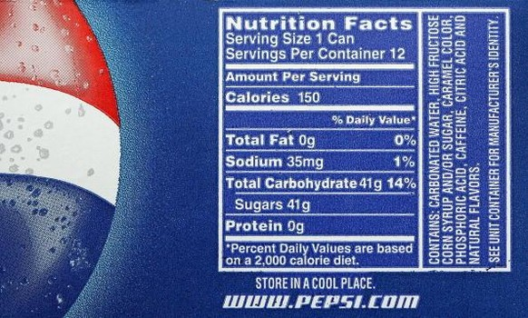

Look at the label – how much sugar? 41 g – that’s a lot. Is there any vitamins? (no) Protein? (no)
Do you think it will help this soccer player be stronger? Will it give him the nutrients he needs to play soccer? (no)

What about this ad? (point to the Got Milk ad)
Who is this?

(Answer: He is best known as “The Rock” – his name is Dwyane Johnson. He was a famous wrestler and now he is in movies.
about “The Rock”
http://en.wikipedia.org/wiki/Dwayne_Johnson)

What do you think he is doing and feeling in this ad?

(Answer: he is helping rescue the cat, he is looking strong)

Read it aloud: “Protein to save the day. 8 grams in every 8 oz. glass”

How does the picture of The Rock help us to believe these words? What is the message here?

(Answer: he looks strong and protein can help you be strong, too).

Do you see these words? (point to and read “Got Milk?”)

That is called the slogan. A slogan is a short phrase or a few words used in advertising for a certain brand or product (e.g., “Milk – It Does a Body Good”). It tells you something about the brand and helps you to remember the ad.

- EXAGGERATION

Show Eggo Parade the Waffle ad and read it aloud.(POWERPOINT)

Ask: What is the main message in this ad? How do they show or tell you about the message?

Answer: Sometimes advertising goes over-the-top or uses exaggeration. This means that the picture or the words may not be actually true, but they are used to get your attention and try to get you to think something.

Ask: What do you think this picture is trying to say?

Here’s another one that uses this same technique. Show Country Crock Veggies ad.

What are they advertising?

(answer: the kids may say veggies – but it is actually for margarine/butter – the ad is telling them with margarine the veggies will get eaten up fast)

(note there are 2 questions about advertising technique and target audience under each ad. The students can fill it out on their own or you can ask them in class).

- PRODUCT AS HERO

Here’s our last ad for today. POWERPOINT

(Show Welch’s grape juice – plump, juicy, delicious ad and read it aloud)

Ask: What is the main message in this ad? How do they convey/tell you about the message?

This ad shows a big visual. In this ad, there are no famous people or characters, the food or product is the hero. For food advertising, a special photographer is used to make the food look really really yummy. Can you see how they zoomed in on the grapes and made them look very big and very fresh? Now, let’s read the word, “Plump, Juicy, Delicious.” These are adjectives or describing words. POWERPOINT

In this case the picture/visual and the words go together great.

What about grape juice? Do we think it is a healthy food?

(answer: yes and no)

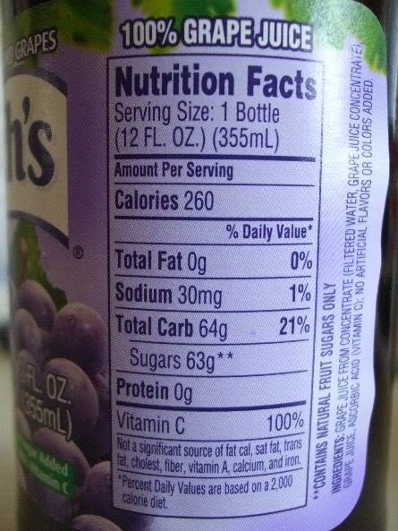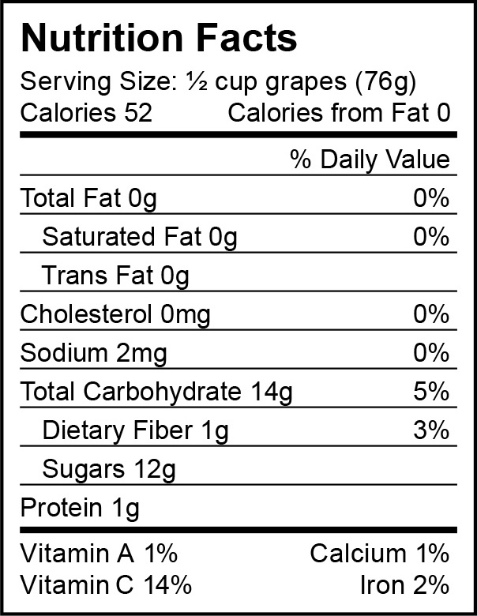

Nutritional facts – grape juice – how many grapes are in there?
Ingredients says grape juice from concentrate – it has 100% of Vitamin C, which is great, but it also has 63 g of sugar, that’s a lot of sugar. It would be better to eat grapes than drink the juice.

BRAIN BREAK

Part IV. ACTIVITY: APPLY WHAT YOU LEARN (10-15 minutes)
There is space for this activity in the children’s packet. It allows them to practice /apply what they learned.

Optional (snack: carrots)

Let’s try out our new techniques. Let’s think of advertising for a carrot.

A carrot is part of which food group?

(Answer it is a vegetable)
http://www.choosemyplate.gov/food-groups/vegetables.html

How much vegetables should your age group have each day?
(answer: about 1 ½ to 2 cups)
http://www.choosemyplate.gov/printpages/MyPlateFoodGroups/Vegetables/food-groups.vegetables-amount.pdf

So we want children to eat vegetables to make their body strong. How can we make advertising for a carrot?

How can we use a character to sell a carrot?

Can anyone draw a character?

How can we use a famous person?

Who could we use in our ad? (why?)

How can we make a funny or exaggerated picture?

What are some words to describe a carrot? (adjectives)

What is an informative claim or fact about carrots? (answer – look to the nutrition facts label)

How can we draw a carrot to make it look really yummy?

(show POWERPOINT pictures of real-life carrot package – Frozen MOVIE)

Packages are another kind of advertising. These carrot packages showed the princess from the movie FROZEN. There is a special deal if you buy the carrots, you can get a coupon for the movie. This type of promotion encourages people to buy the product.

Great job.

